8/1/2017

|  |  |
| --- | --- |
| Name | Email |
| Akshay Ghorpade | akshayghorpade@csu.fullerton.edu |
| Alakananda Goswami | alaka90.dgp@csu.fullerton.edu |
| Charushila Awhad | charushila.awhad[@csu.fullerton.edu](mailto:bhamur@csu.fullerton.edu%20) |
| Nikolaos Hatzopoulos | nickhatz@csu.fullerton.edu |
| Saranya Arunachalam | saranarun@csu.fullerton.edu |

Case Study using Selenium IDE

&

WebDriver

CPSC 542 - Software Verification & Validation

CALIFORNIA STATE UNIVERSITY, FULLERTON

Table of Contents

1. Introduction 2

1.1. Selenium IDE (Selenium Integrated Development Environment) 2

1.2. Selenium 1/Selenium-RC (Remote Control) 3

1.3. Selenium WebDriver/Selenium 2.0: 3

1.4. Selenium Grid 3

2. Target System 4

3. Selenium IDE & Web Driver Tests Case and Results 6

3.1. Signup flow 6

3.2. Empty Book categories in Book details page 8

3.3. Search Book name 10

3.4. Add to Cart from home page 12

3.5. Login and Logout 14

3.6. Decrease quantity in Cart 16

3.7. Order Placement Flow 18

3.8. Delivery method not updated 20

3.9. Remove Item from Cart 22

3.10. Decimal points in Item Prices 24

3.11. Checkout flow 26

3.12. Cart Item price not displayed in Order details page 28

3.13. Courier charges not calculated 30

3.14. Order date issue 32

4. Pros and Cons of Selenium 34

5. Conclusion 36

References 37

# Introduction

Selenium is the automated testing tool used for testing web applications. It is one of the best open source tool used for functional or system testing. It supports multiple browsers such as Internet Explorer, Firefox, Safari, etc. and multiple OS such as Linux, Windows, Mac, etc. It can execute a single test case on multiple browser’s platforms.

Selenium was first created by Jason Huggins in 2004. He created it in Chicago while working at ThoughtWorks. Here he was working on one web application. This web application required frequent testing. He realized that repetition of manual testing is very inefficient and time consuming. He created one program in JavaScript that automatically controls the browser’s action. Initially he named it as “JavaScriptTestRunner” that later on renamed it as “Selenium Core”.

The Selenium is not a single tool. It contains several other tools. Each of these tools designed for various test and testing environment. It offers the following set of tools:

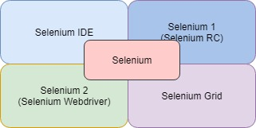

Fig: Selenium tools

## **Selenium IDE (Selenium Integrated Development Environment)**

It is an Integrated Development Environment used for building Selenium test cases. It is one of the simplest frameworks that works with Mozilla Firefox plugin. This plugin will provide an easy-to-use interface to develop and run individual test cases or an entire test suite.

In addition, it has recording feature that keep track of user actions when they perform then it stores it in a reusable script to play it back. It also provides the context menu integrated with Mozilla Firefox browser, which allows to pick from designated location. It also provides the editing feature for more control and precision on test cases. The test cases that was created on this can also run on another browser by Selenium-RC.

## **Selenium 1/Selenium-RC (Remote Control)**

It allows to write automated web-application’s UI test in any programming language with respect to various HTTP websites. Selenium1 or Selenium-RC has two parts.

Client library for any programming language:

It provides an API to test and execute the program on the server. Each implementation offers access to all selenium commands. Its supported API implementation exist in: Java, PHP, .Net, Perl, Python, Ruby, etc.

A server that automatically launches and kills browser as well as act as HTTP proxy for any web

Request that comes from them. It is well known tool for testing AJAX based web UI.

## **Selenium WebDriver/Selenium 2.0:**

Selenium 2.0 is an integration of WebDriver API. It better supports the dynamic web pages in which the elements of the pages will change without itself reloading. It manages the browser by directly communicating with it either locally or remotely. The WebDriver’s main aim is to supply well designed object-oriented application programming interface that will provide a better-quality support for modern, innovative web application testing problems. It is a successor of selenium RC.

“Selenium 1.0+ WebDriver = Selenium 2.0”

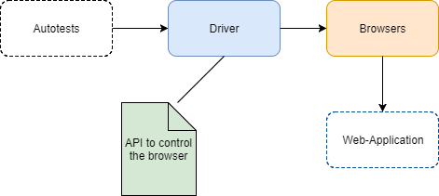

Fig: Selenium 2.0 Architecture

The architecture of selenium WebDriver is simpler than Selenium RC. WebDriver is faster than other tools. It interacts with page in more realistically.

## **Selenium Grid**

It is a tool that work with Selenium RC to run parallel test across various machines and various browsers at the same time. Parallel execution is nothing but running several tests at once. It uses hub-and-node concept.

# Target System

"Electronic commerce" is the process by which businesses and consumers buy and sell goods and services through an electronic medium."

E-Commerce emerged in the early 1990s and had experienced an accelerated usage since then. Today, as we all know most of the companies have an online presence, in fact, business through the internet has become an absolute necessity. As per the survey, 60% of shoppers in developed countries go to the Internet to buy goods and services. The key word here is 'convenience.' Unlike a regular store, an Ecommerce store stays up and running 24/7. Customers can get online and buy products at any time of the day from the comfort of their house. The key benefits of e-commerce and the online shopping system are:

* A comprehensive description of any commodity with data sheets that contain all the features and characteristics of products.
* Ability to reach a larger market as e-commerce thrives through the traffic it gets from the search engines.
* Extremely useful to for any novice to research about a product through the ratings and loads of customer experiences.
* Computerized system provides higher competency.
* Less maintenance cost in terms of fewer employees

All the advantages mentioned above of e-commerce and online shopping motivated our team to build a website facilitating online book shopping for our purpose of selenium case study. Buying books over the web at an online book shop can be an interesting and informative buying experience. It allows us to buy books suited to our interests and that too while relaxing at home at any time of the day or night. Few of the compelling benefits of this website would be:

* The Stock- Physical bookstores are restricted by space limitations, but our online bookstore does not have these restrictions and offers a variety of authors and titles
* Next is convenience. One can easily order books from our online bookstore without the restrictions of specific store timings, long lines at the cash counter or the hassles of parking or traffic
* Another advantage would be the cost; customers would be able to compare prices from several other websites and choose wisely; customers would also be able to hunt for great deals and discounts, orders costing more than a certain amount of money would get free shipping benefits
* Customers are free to view the comments and feedbacks posted by other customers while researching about a book and making a purchase

We have created a simple website for our selenium testing, which has the below-mentioned features:

* Every new user will be able to register to the website with a valid username and password using the 'sign up' button on the homepage of the website. On successful registration user will receive a display message
* Users will be able to browse through the 'categories' section of the website to view the bookstore collection under each category
* A specific 'search' bar at the homepage of the website would allow users to research about a specific book of interest
* Any item purchased would have to be added to the 'cart' before checkout, and the specific delivery option needs to be selected from the cabinet
* Before checkout, user would need to enter his/her details to ensure accurate delivery of the item
* Upon clicking the 'logout' option, users would be redirected to the initial login screen

We are all aware of the major shift in the trend of buying books from conventional bookstores. Although the online store would not be able to recreate the feeling which one gets while walking into a physical store, but the benefits offered by our bookstore cannot be ignored. With the plethora of advantages of our online bookstore, we are convinced to provide an enjoyable experience to the online customers.

# Selenium IDE & Web Driver Tests Case and Results



## **Signup flow**

|  |  |  |
| --- | --- | --- |
| Test Case ID: | 3.1. Sign up Flow | |
| Test Objective: | To check if the user can register to Bookstore using valid username and password | |
| Test Data: | Username: myuid89@yahoo.com  Password: test@123 | |
| Prerequisites | The Bookstore website should be running | |
| Procedure: | Expected Result | Actual Result |
| 1. User clicks on Sign Up button 2. User provides valid username and password 3. User will be able to sign up and get a message “Thank you for registering! Please, log in to make orders” | The user shall be able to register to the Bookstore website | The user can register to the Bookstore website |
| Test Case Result: | Pass | |

Selenium IDE Test:

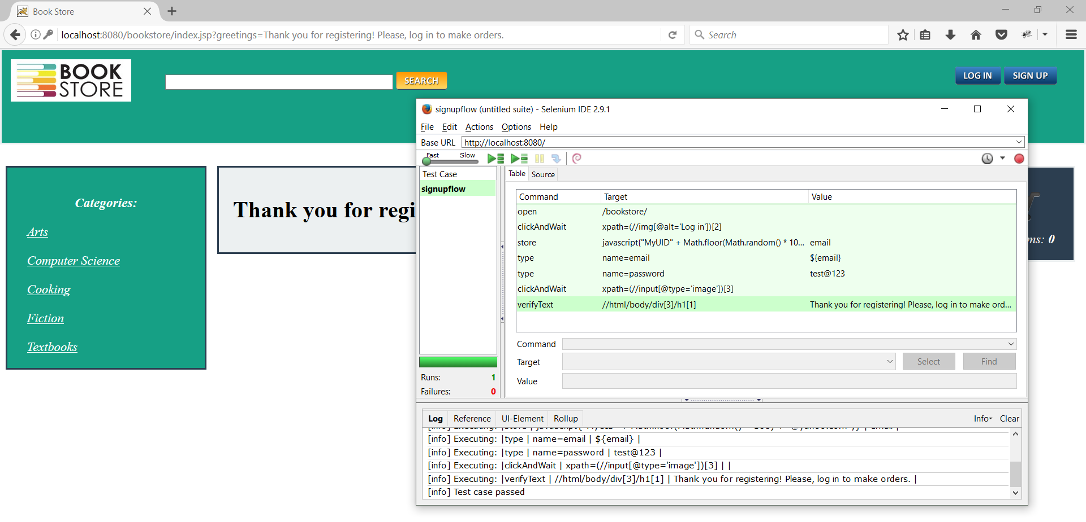

Selenium WebDriver Test:

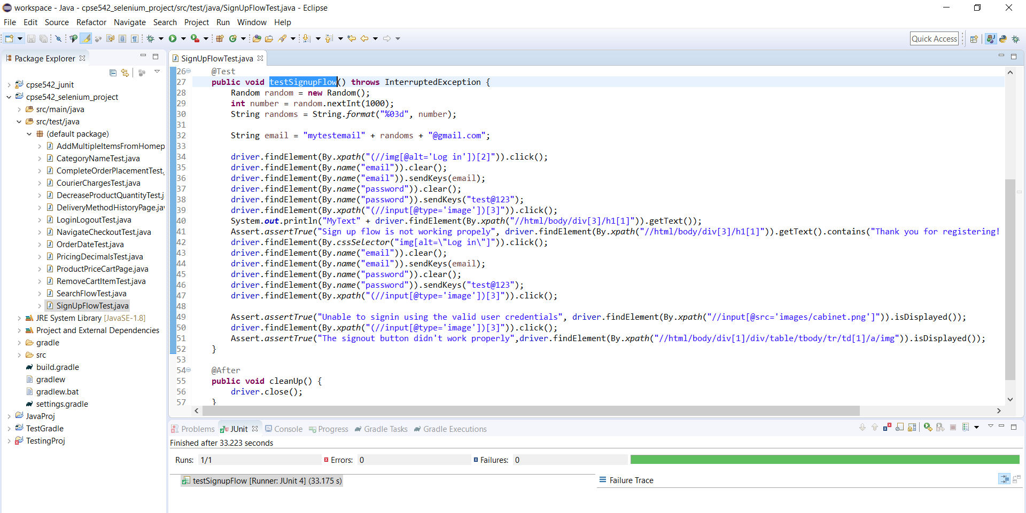

Test Result: The user can register to Bookstore website

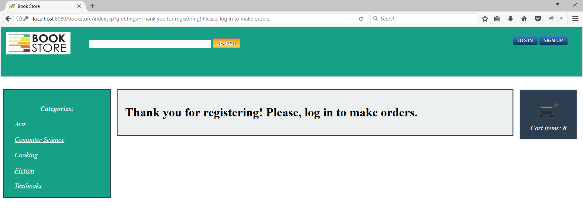

## **Empty Book categories in Book details page**

|  |  |  |
| --- | --- | --- |
| Test Case ID: | 3.2. Empty Book categories in Book details page | |
| Test Objective: | To check if the categories section in the Book details page is correctly updated | |
| Test Data: | For Book with Title: “Everyday Super Food”  Categories: Cooking | |
| Prerequisites | The Bookstore website should be running | |
| Procedure: | Expected Result | Actual Result |
| 1. User logins to the website using valid username and password 2. User views the Book **“**Everyday Super Food**”** details from Homepage 3. Check if the Categories section has “Cooking” | The user shall be able to view a valid entry in the categories section | The user is not able to view a valid entry in the categories section. It is blank |
| Test Case Result: | Fail | |

Selenium IDE Test:

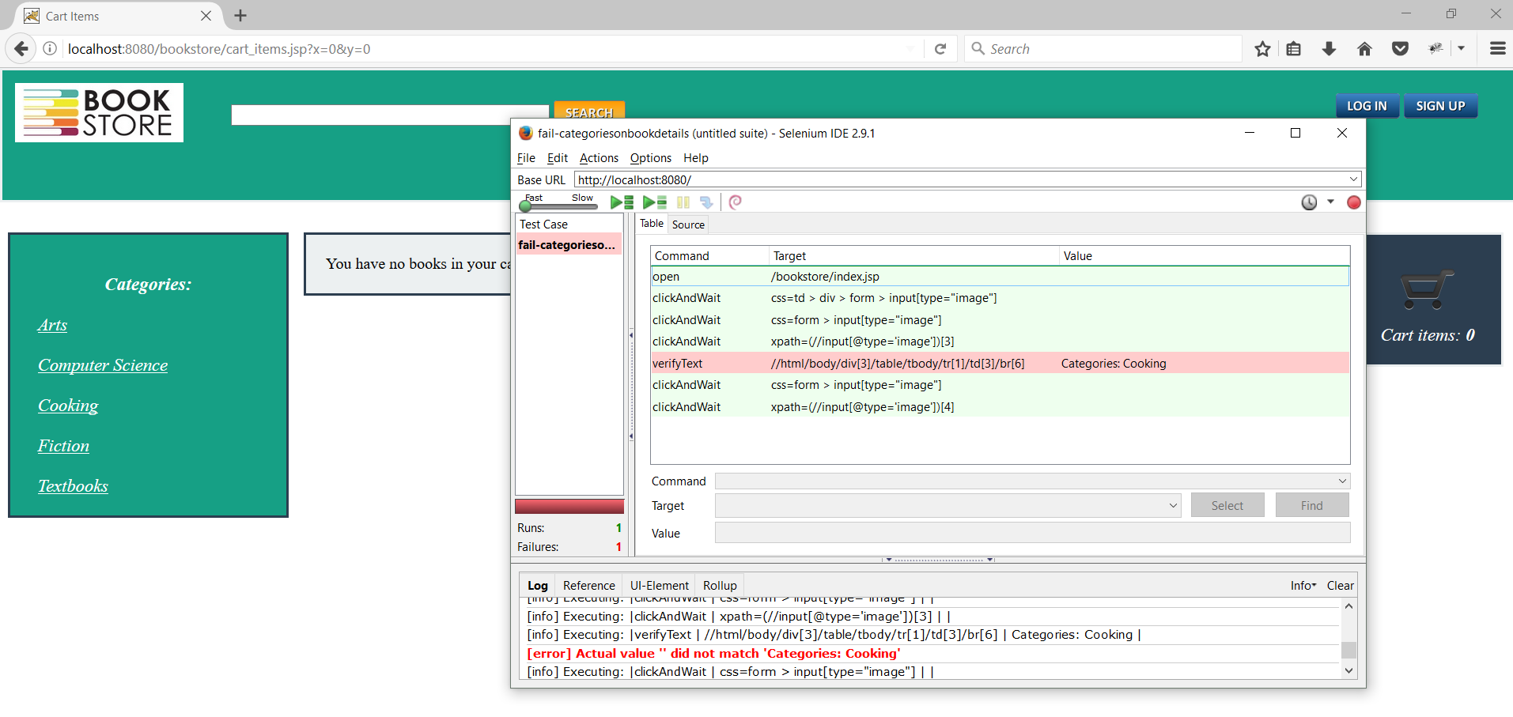

Selenium WebDriver Test:

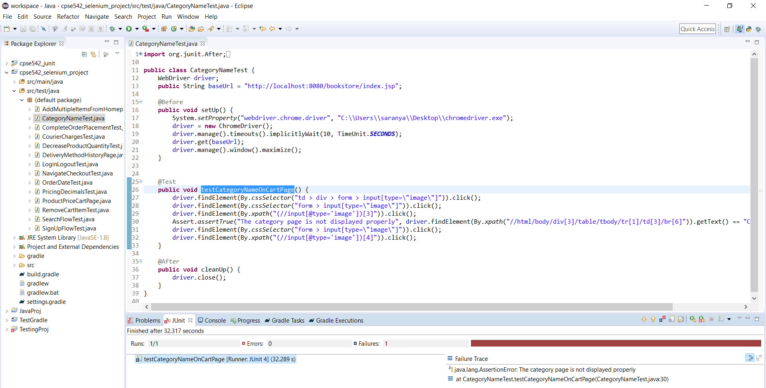

Test Result: The Categories section is blank in the Book details page

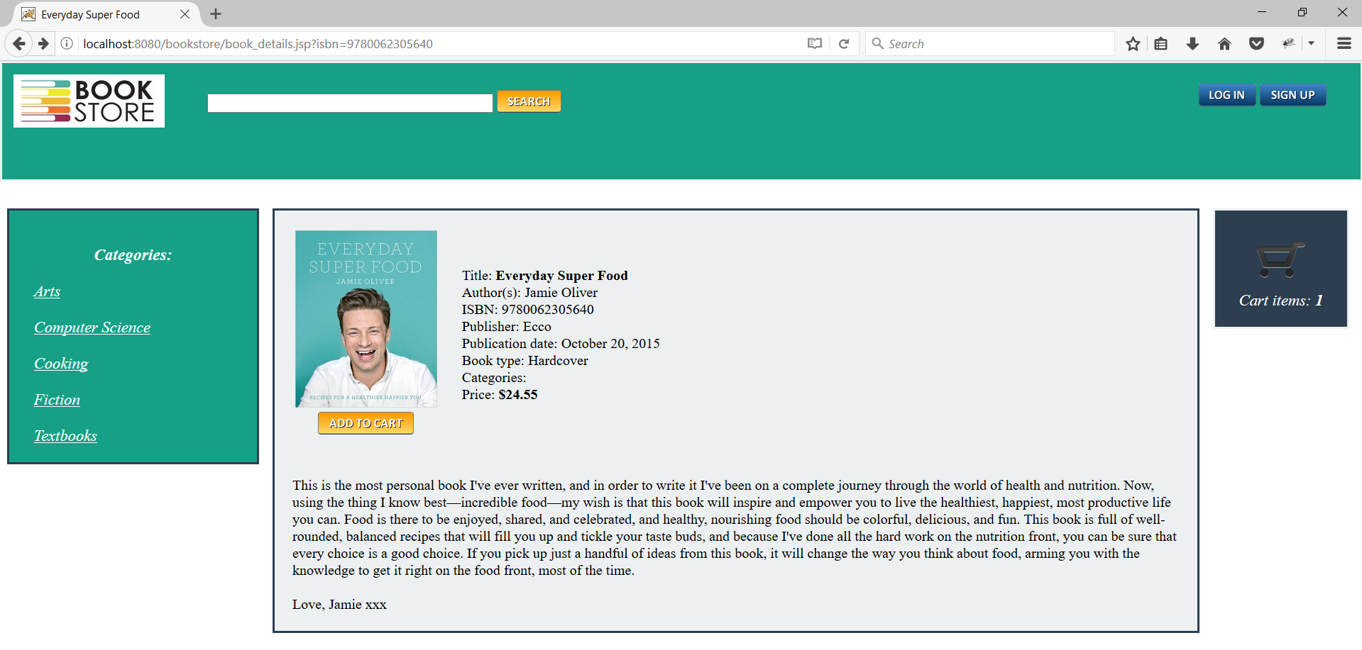

## **Search Book name**

|  |  |  |
| --- | --- | --- |
| Test Case ID: | 3.3. Search Book name | |
| Test Objective: | To search for the book using keywords | |
| Test Data: | Book name: “Everyday Super Food”, “everyday”, “super” | |
| Prerequisites | The Bookstore website should be running | |
| Procedure: | Expected Result | Actual Result |
| 1. User logins to the website using valid username and password 2. User types “Everyday Super Food” in the search bar of the homepage or any string like “everyday” or “super” | The user shall be able to view the correct book in the search results i.e. “Everyday Super Food” | The user shall can view the correct book in the search results i.e. “Everyday Super Food” |
| Test Case Result: | Pass | |

Selenium IDE Test:

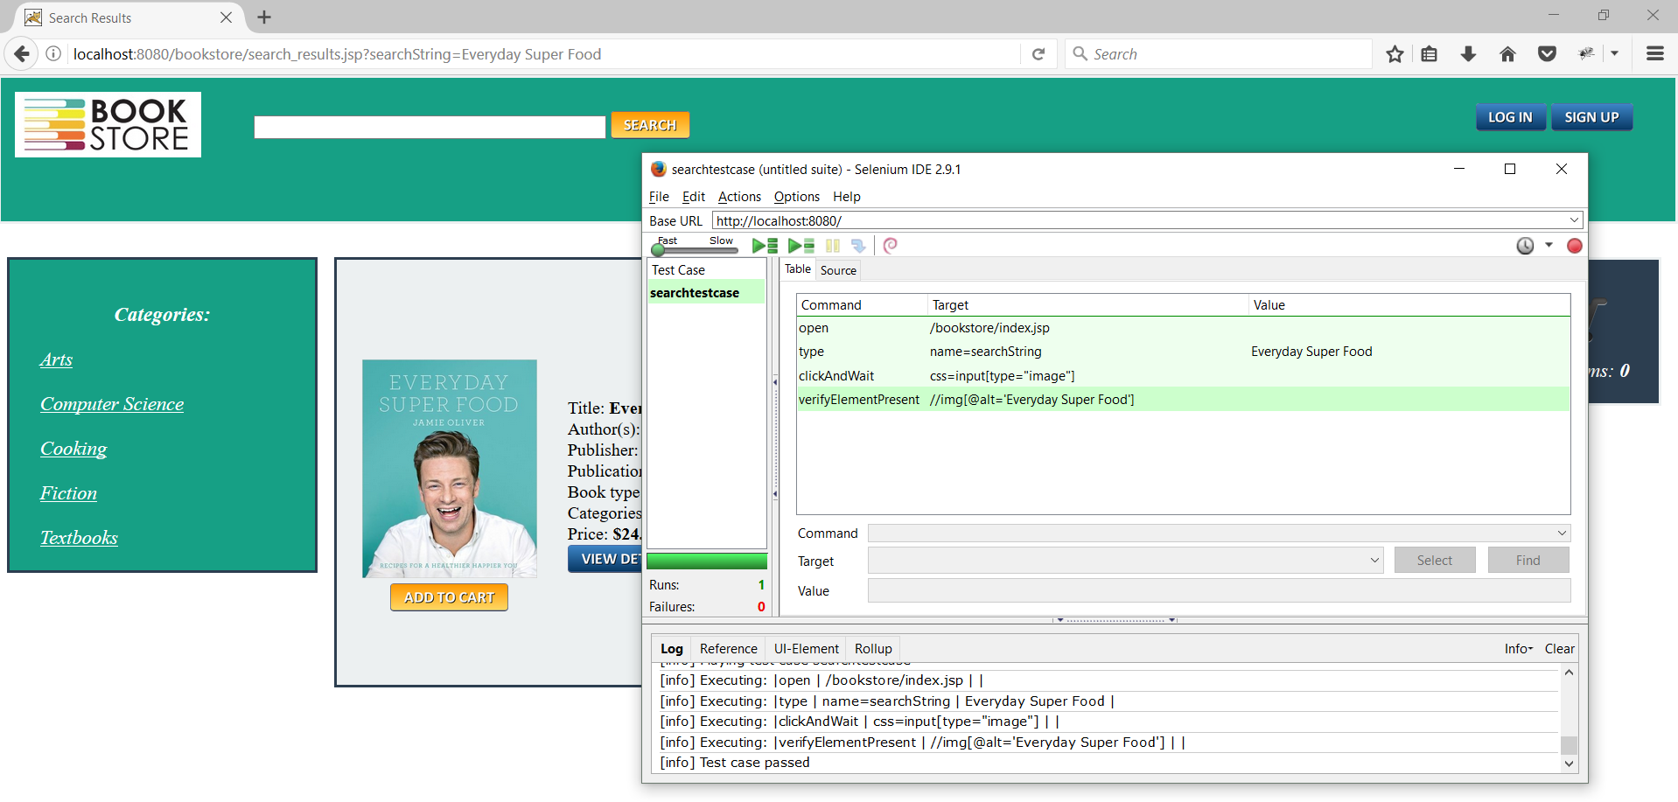

Selenium WebDriver Test:

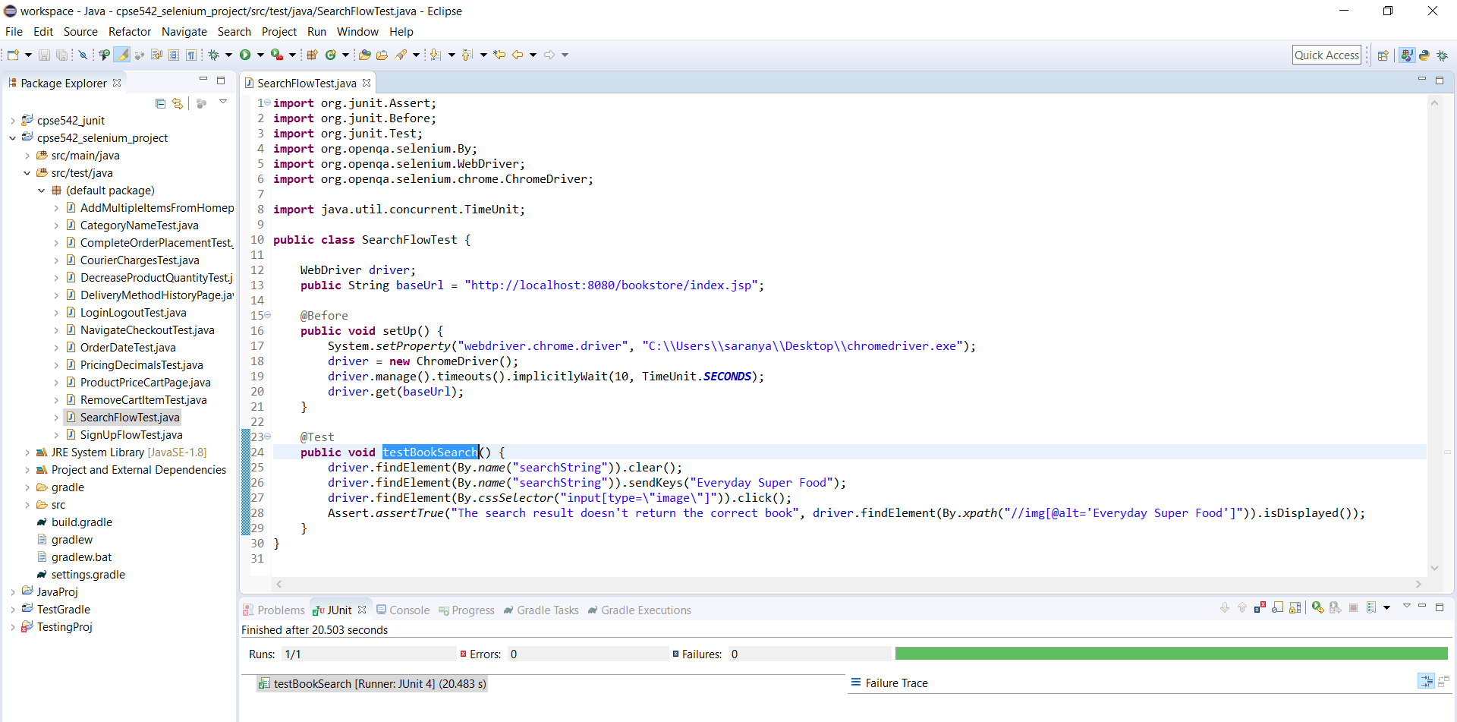

Test Result: The search results provide the exact book “Everyday Super Food”

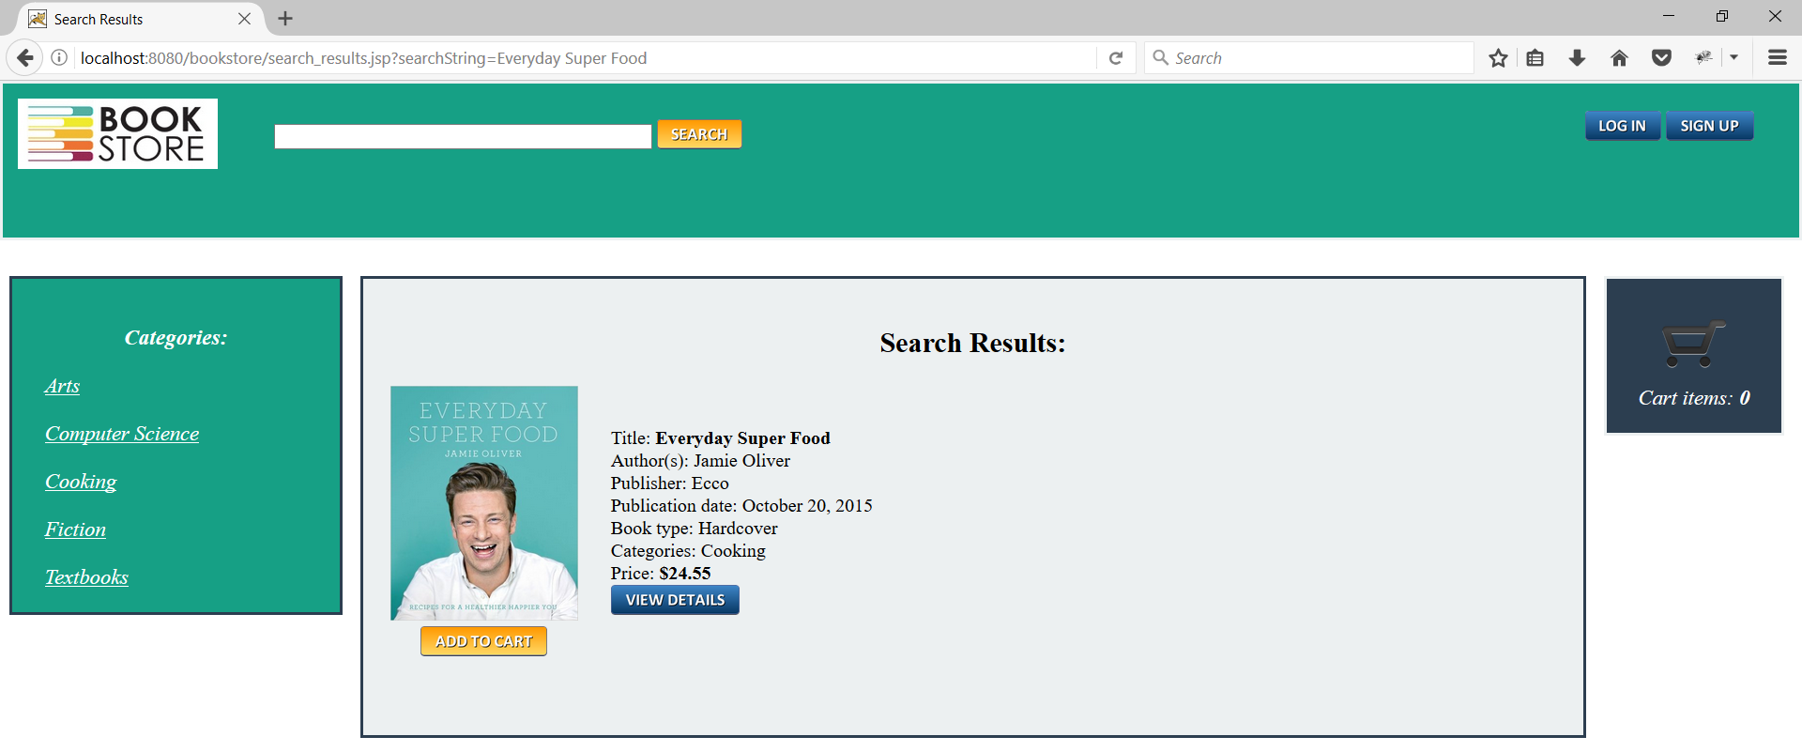

## **Add to Cart from home page**

|  |  |  |
| --- | --- | --- |
| Test Case ID: | 3.4. Add to Cart from home page | |
| Test Objective: | To add book to Cart from Home page | |
| Test Data: | Book name: “Everyday Super Food” | |
| Prerequisites | The Bookstore website should be running | |
| Procedure: | Expected Result | Actual Result |
| 1. User logins to the website using valid username and password 2. User clicks multiple times on Add to Cart for the book “Everyday Super Food” from Home page | The Cart value should increase | The Cart value doesn’t increase and remain at the value 1 |
| Test Case Result: | Fail | |

Selenium IDE Test:

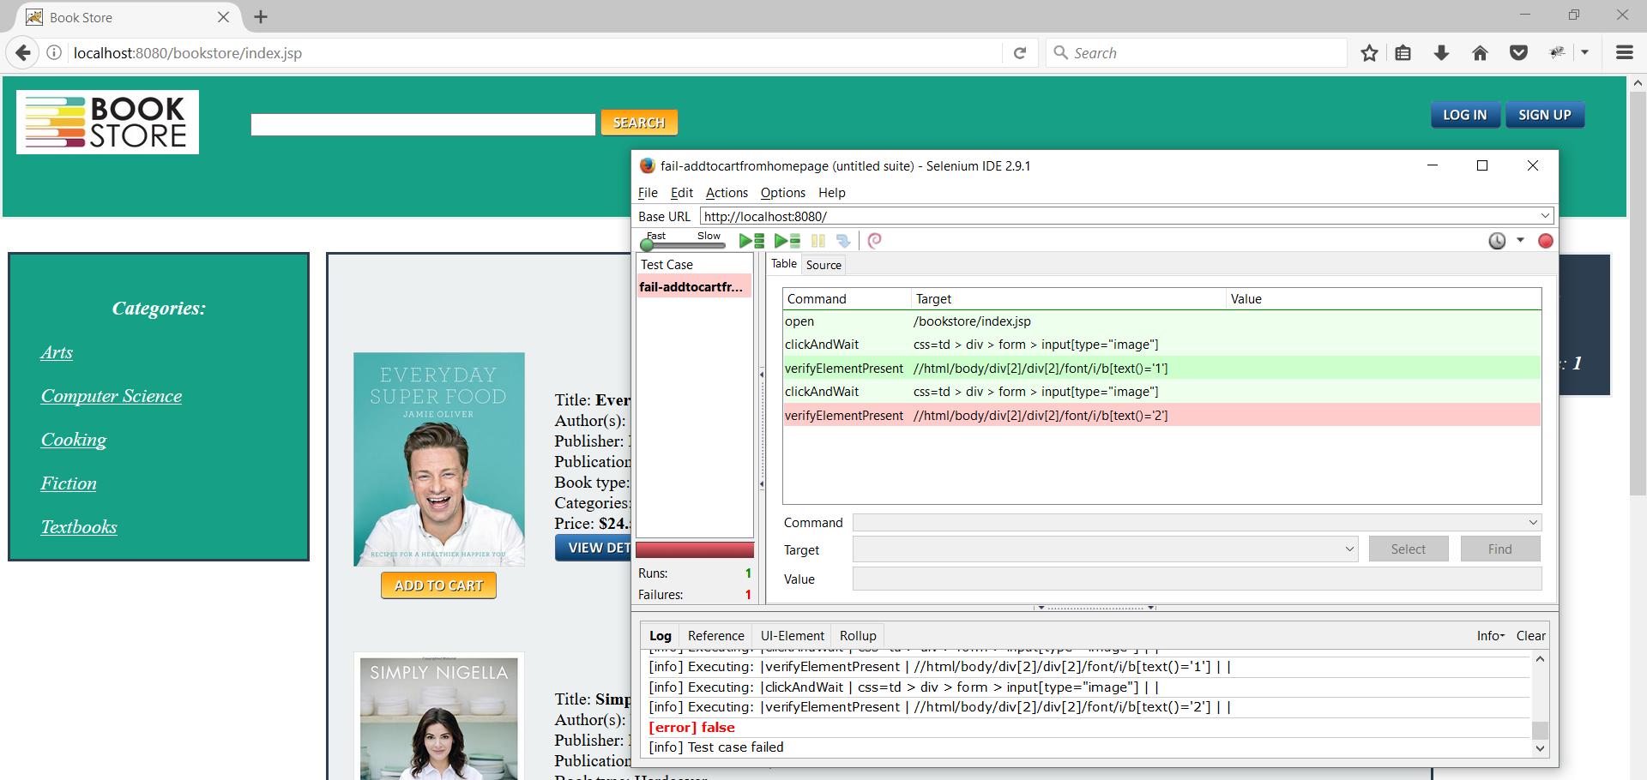

Selenium WebDriver Test:

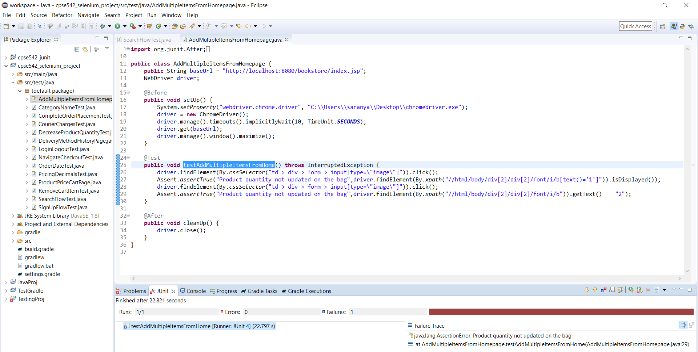

Test Results: The Cart value doesn’t increase and remain at the value 1

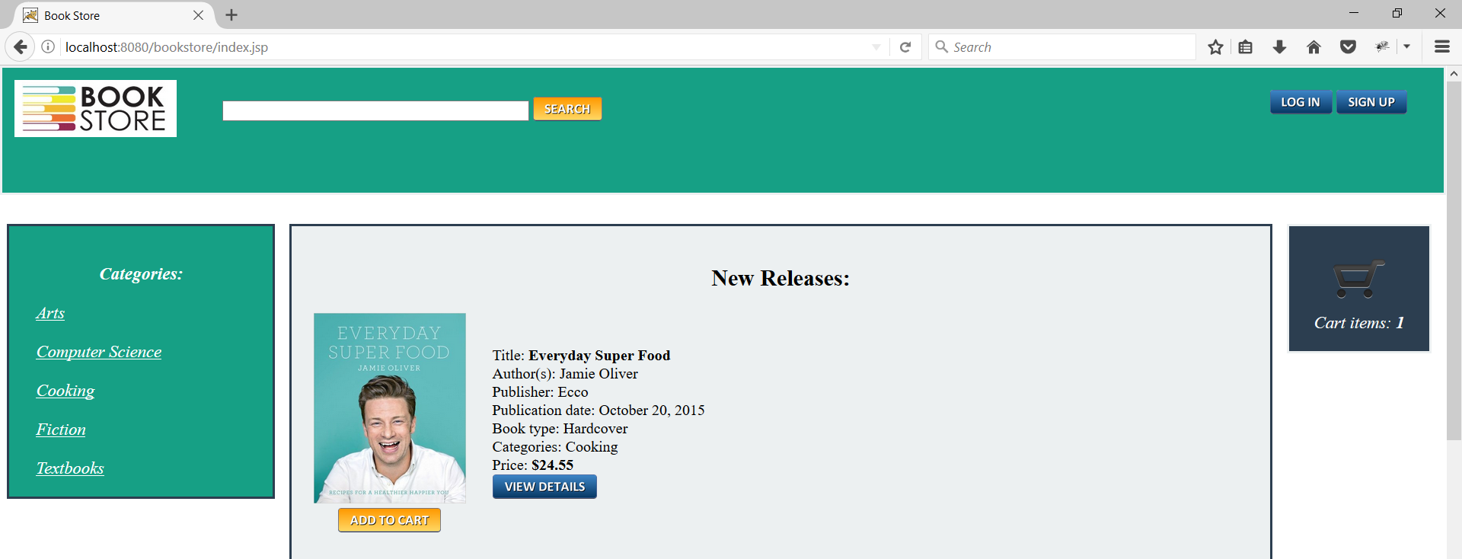

## **Login and Logout**

|  |  |  |
| --- | --- | --- |
| Test Case ID: | 3.5. Login and Logout | |
| Test Objective: | To check if the user can login with valid username and password and logout after shopping | |
| Test Data: | Username: myuid89@yahoo.com  Password: test@123 | |
| Prerequisites | • The Bookstore website should be running  • Valid user credentials (Username and Password) | |
| Procedure: | Expected Result | Actual Result |
| 1. User connects to local server with username and password. 2. Send a request to the server to validate username and password. 3. User logins to the Bookstore 4. After shopping user logs out of the Bookstore | The user shall be able to login logout of the Bookstore website | The user can login & logout of the Bookstore website |
| Test Case Result: | Pass | |

Selenium IDE Test:

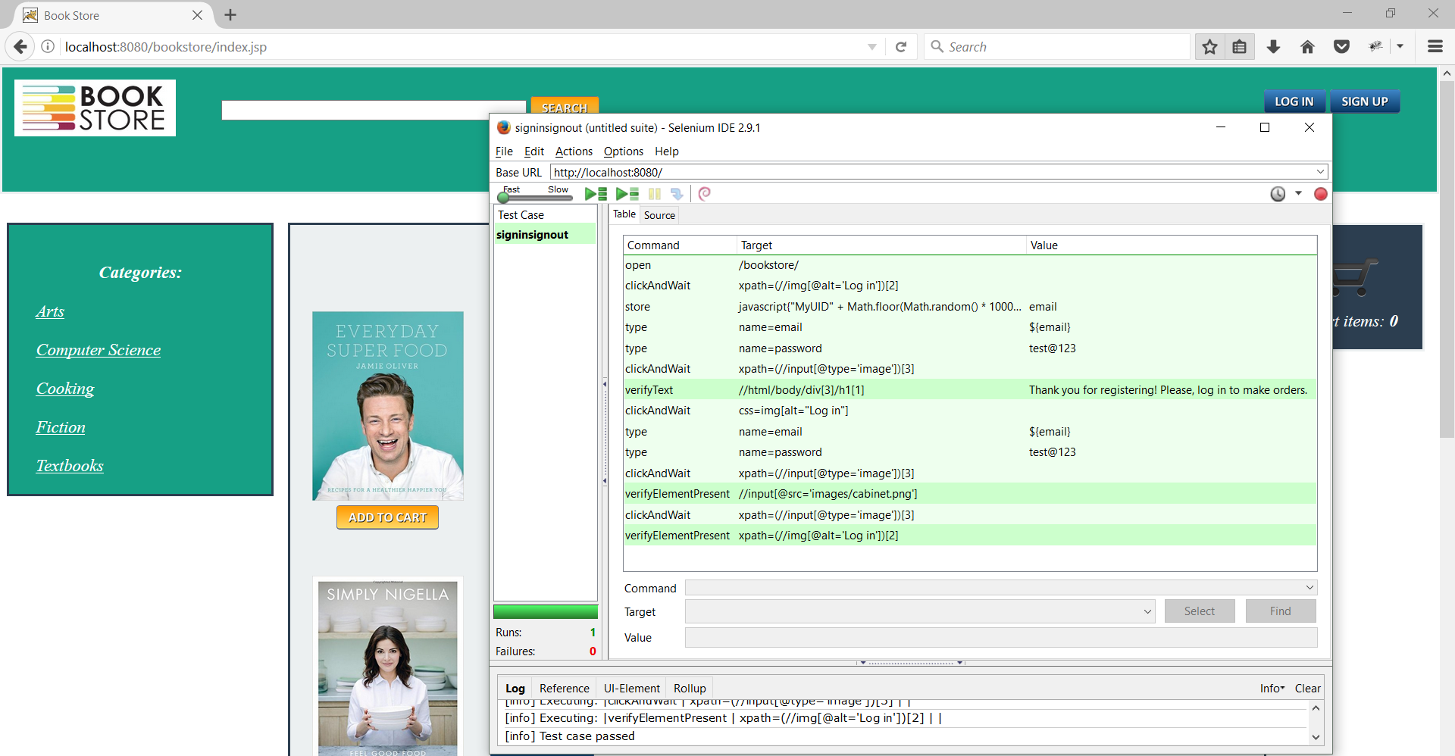

Selenium WebDriver Test:

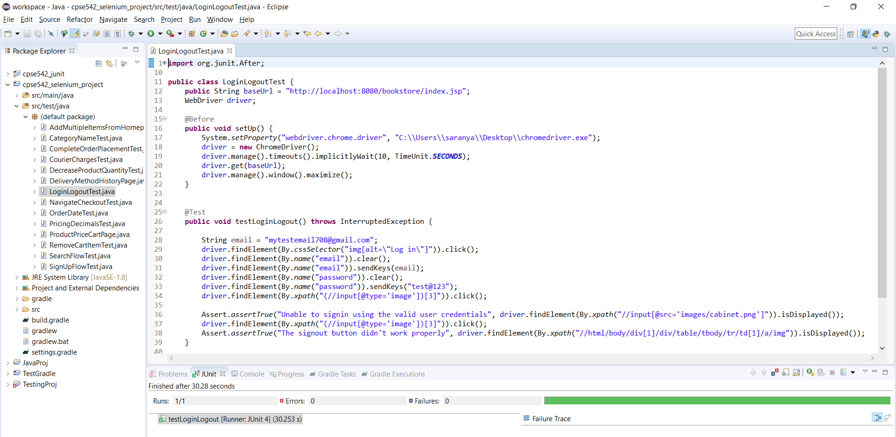

Test result: User will be able to login & logout and come back to homepage

Login:

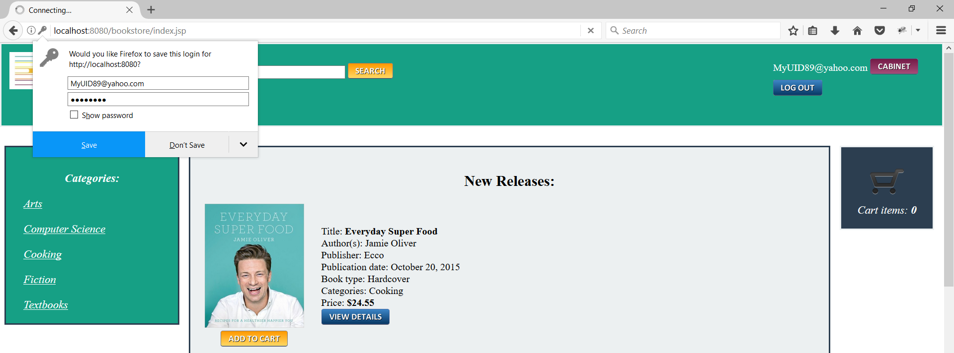

Logout:

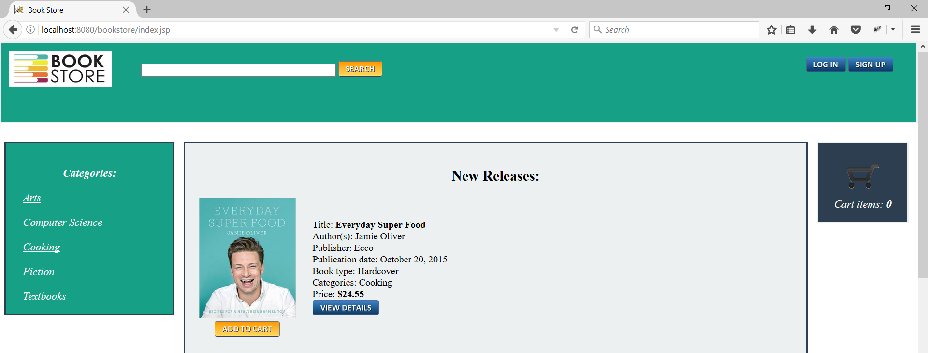

## **Decrease quantity in Cart**

|  |  |  |
| --- | --- | --- |
| Test Case ID: | 3.6 Decrease quantity in Cart | |
| Test Objective: | To check if the quantity value in the Cart can be decreased | |
| Test Data: | Quantity | |
| Prerequisites | The Bookstore website should be running | |
| Procedure: | Expected Result | Actual Result |
| 1. User logins to the website using valid username and password 2. User select the book to be purchased and add to the Cart 3. User selects the Cart to add quantity 4. User clicks the down arrow to decrease quantity | The user shall be able to decrease the book quantity | The user is not able to decrease the book quantity |
| Test Case Result: | Fail | |



## 

Selenium IDE Test:

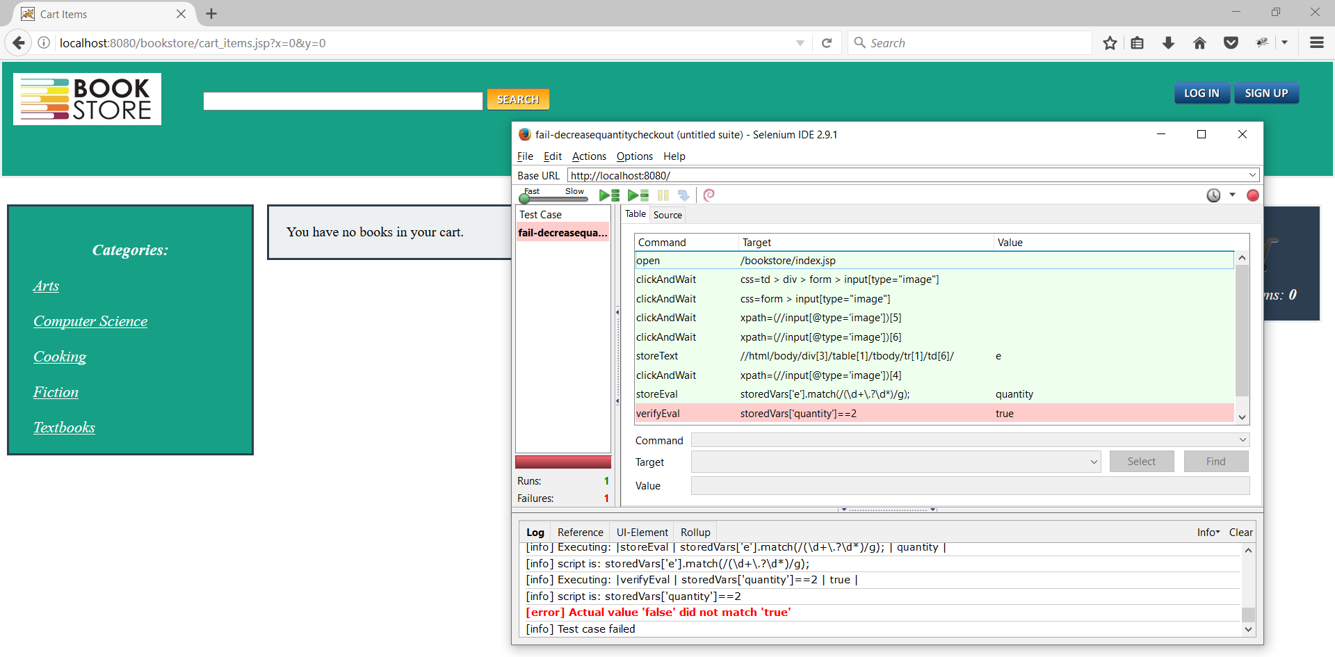

Selenium WebDriver Test:

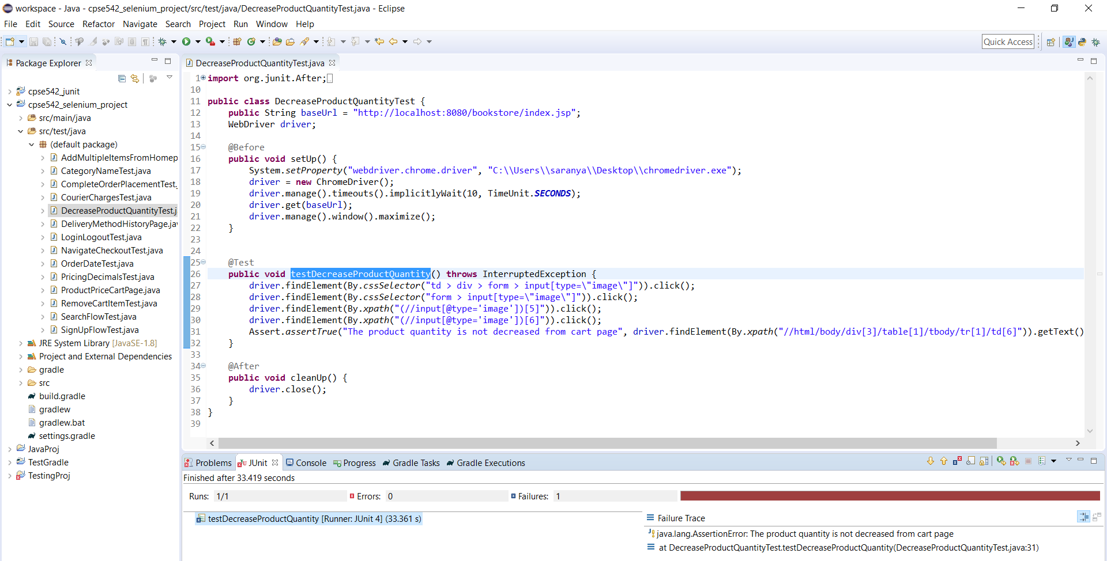

Test Result: The user is not able to decrease the book quantity

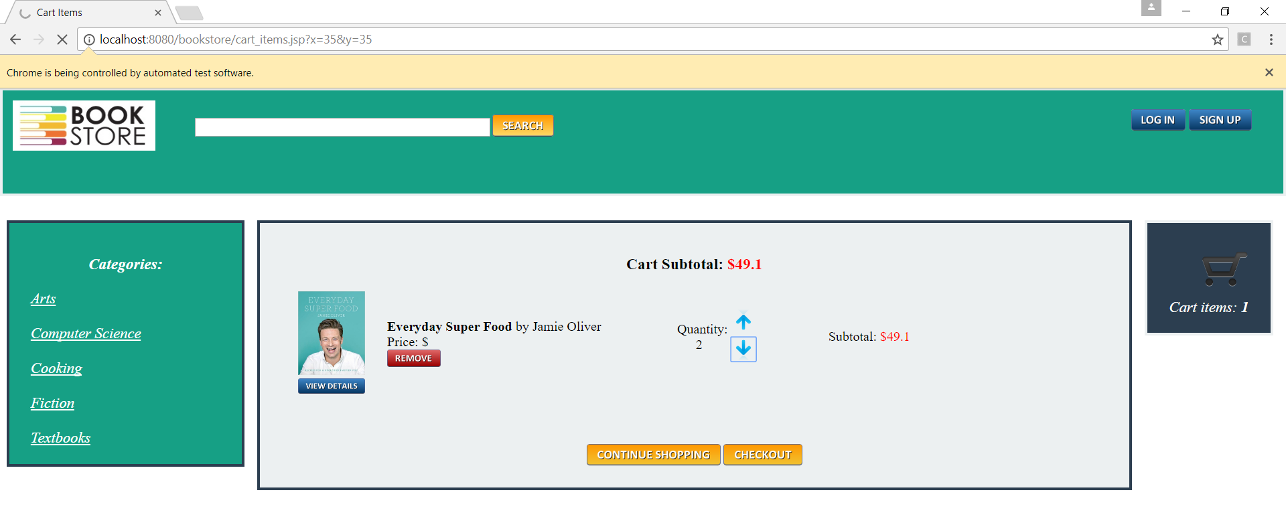

## **Order Placement Flow**

|  |  |  |
| --- | --- | --- |
| Test Case ID: | 3.7. Order Placement Flow | |
| Test Objective: | To check if the user can place an order | |
| Test Data: |  | |
| Prerequisites | The Bookstore website should be running | |
| Procedure: | Expected Result | Actual Result |
| 1. User logins to the website using valid username and password 2. User selects the book to be purchased and add to the Cart 3. User selects the cart and checkout to provide personal details for delivery 4. User confirms the order summary | The user shall be able to place an order and receive the message “Your order have been successfully added. Thank you! You can view your order history in your cabinet.” | The user can place an order and view the message “Your order have been successfully added. Thank you! You can view your order history in your cabinet.” |
| Test Case Result: | Pass | |

Selenium IDE Test:

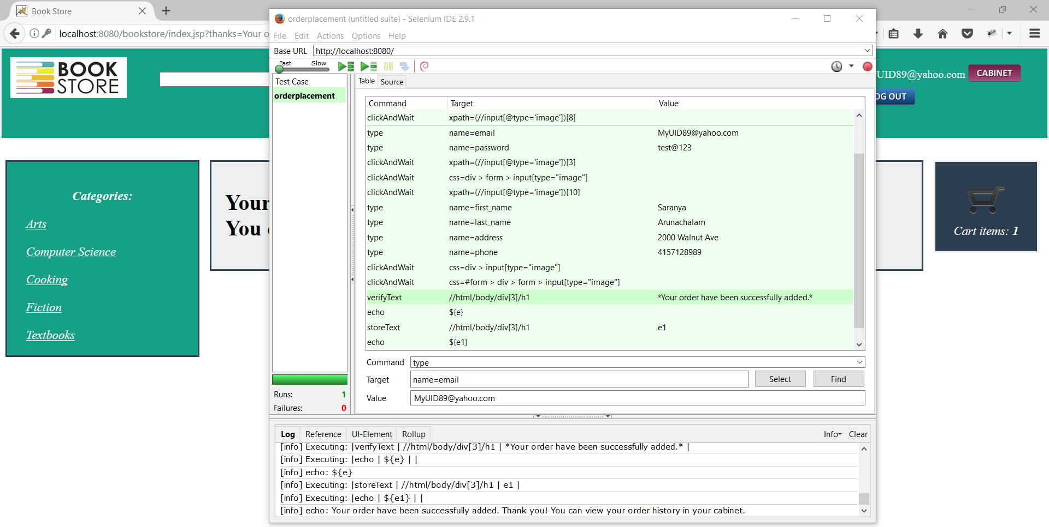

Selenium WebDriver Test:

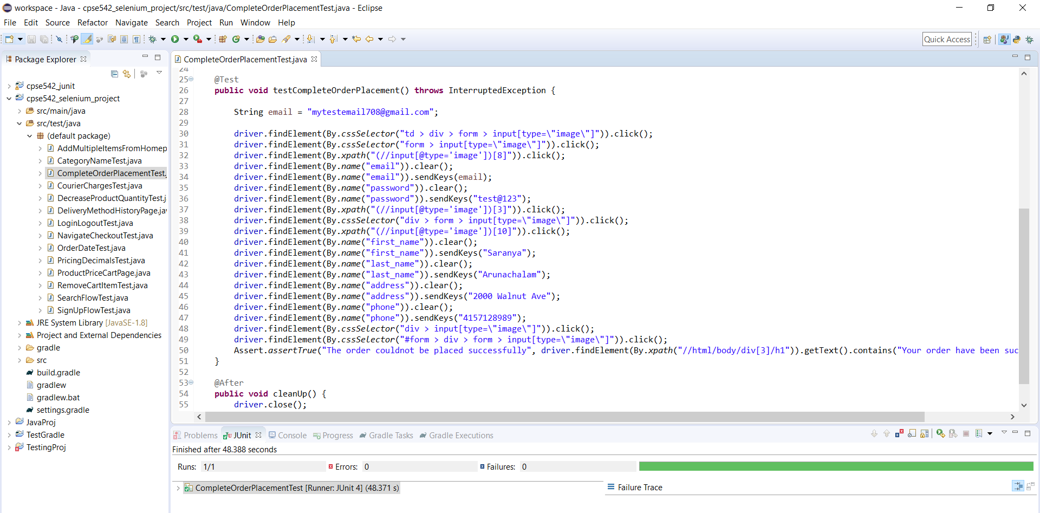

Test Result: The user can place an order

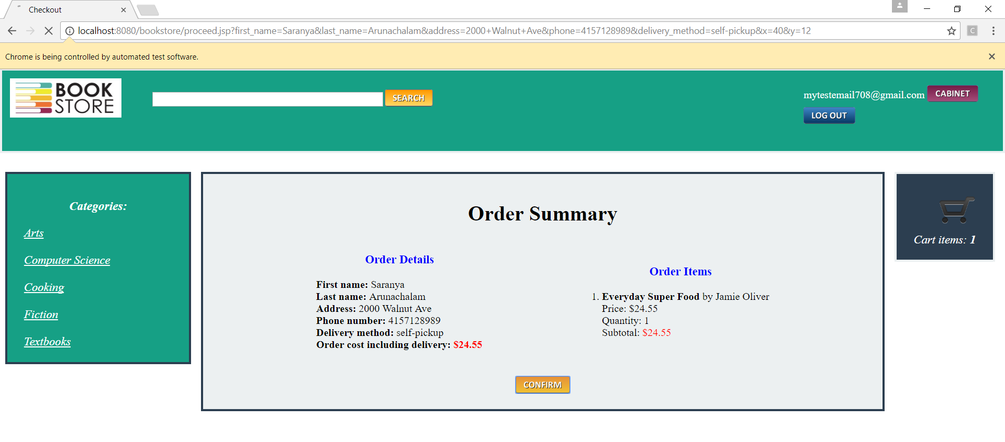

## **Delivery method not updated**

|  |  |  |
| --- | --- | --- |
| Test Case ID: | 3.8. Delivery method not updated | |
| Test Objective: | To check if the delivery method is updated properly in the Cabinet section | |
| Test Data: | Delivery method | |
| Prerequisites | The Bookstore website should be running | |
| Procedure: | Expected Result | Actual Result |
| 1. User logins to the website using valid username and password 2. User selects the book to be purchased and add to the Cart 3. User selects the cart and checkout to provide personal details for delivery 4. User confirms the order summary 5. User checks the delivery method in the Cabinet | The user shall be able view the delivery method in the order history of the Cabinet | The user is not able to view the delivery method in the order history of the Cabinet |
| Test Case Result: | Fail | |

Selenium IDE Test:

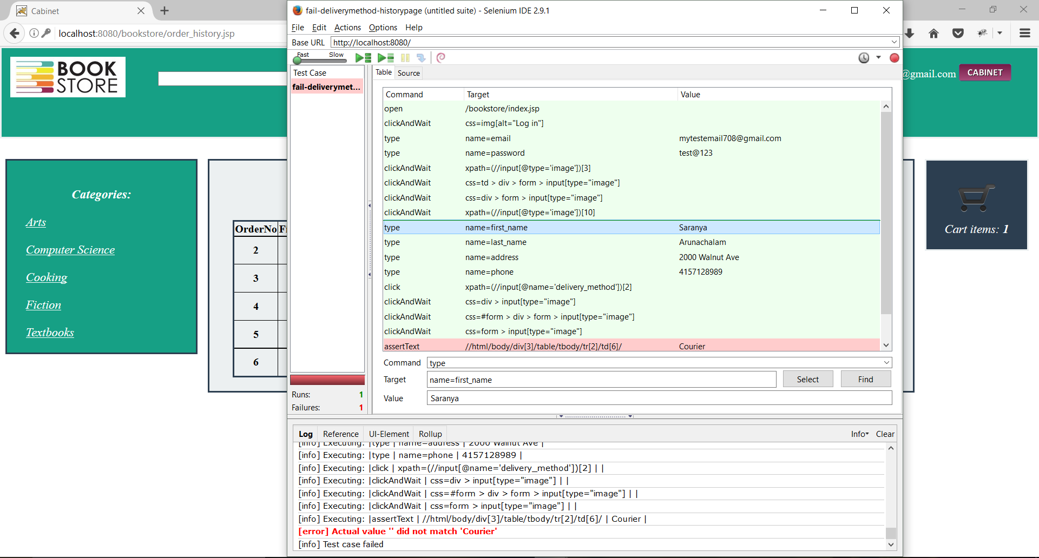

Selenium WebDriver Test:

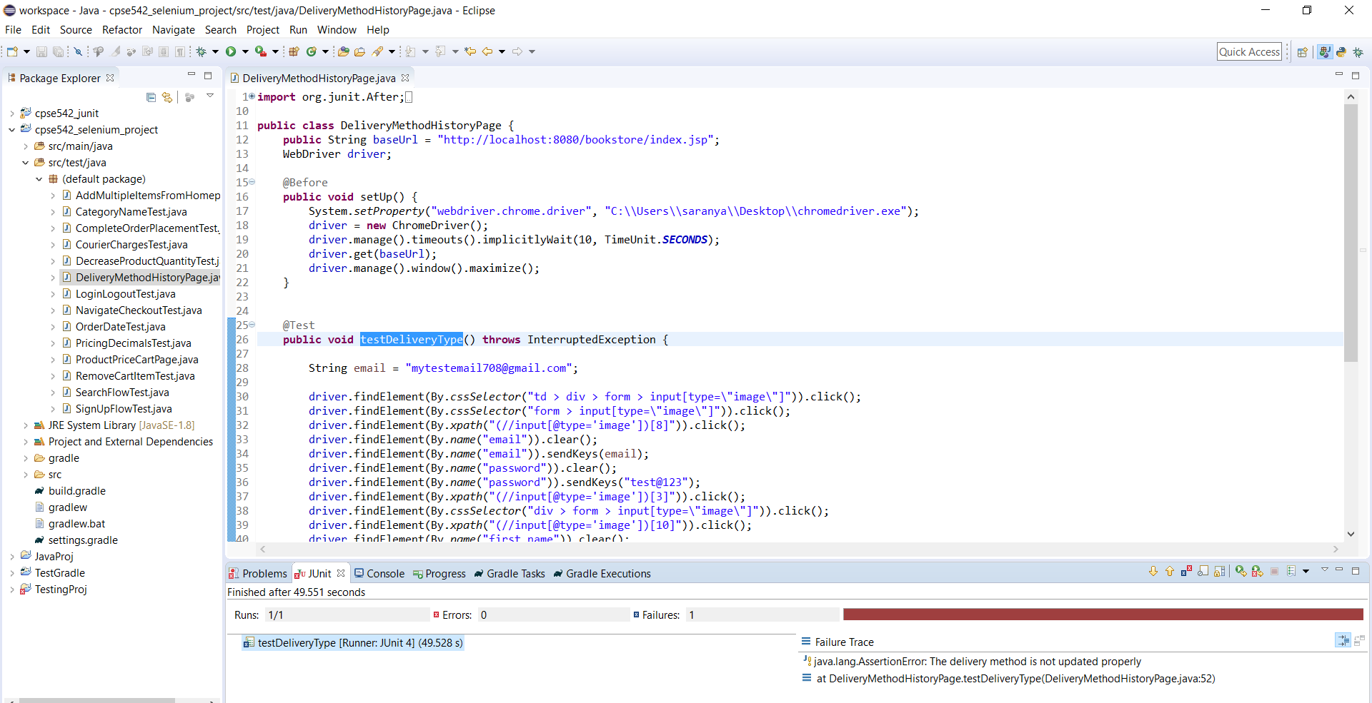

Test Result: The user is not able to view the delivery method in the order history of the Cabinet

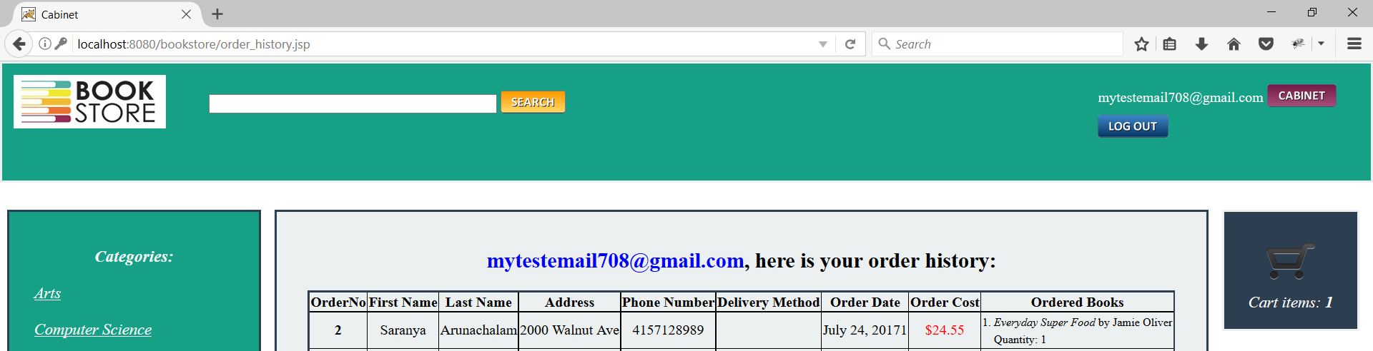

## **Remove Item from Cart**

|  |  |  |
| --- | --- | --- |
| Test Case ID: | 3.9. Remove Item from Cart | |
| Test Objective: | To check if the item in the cart can be removed | |
| Test Data: | Cart items | |
| Prerequisites | The Bookstore website should be running | |
| Procedure: | Expected Result | Actual Result |
| 1. User logins to the website using valid username and password 2. User selects the book to be purchased and add to the Cart 3. User selects the cart and click on Remove button | The user shall be able to remove the item from the cart | The user can remove the item from the cart |
| Test Case Result: | Pass | |

Selenium IDE Test:

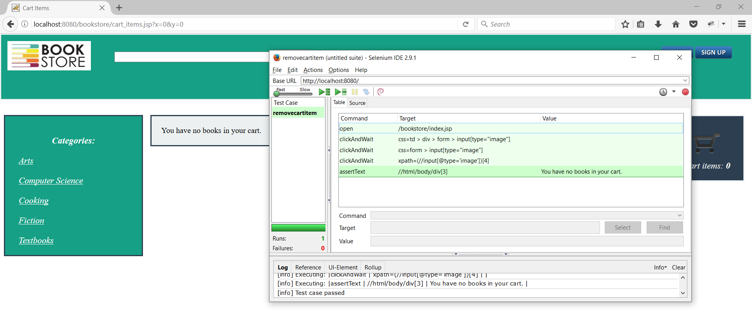

Selenium WebDriver Test:

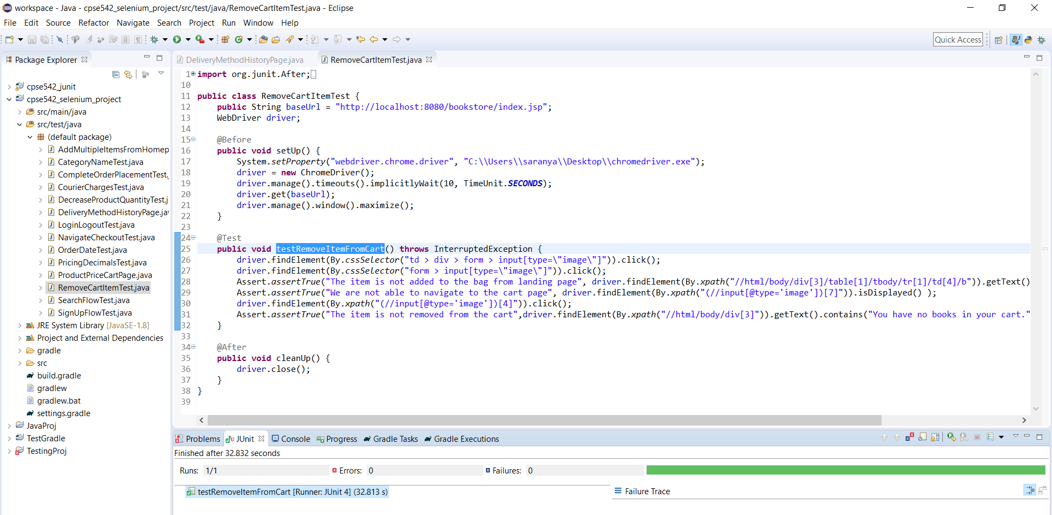

Test Result: The user can remove the item from the cart

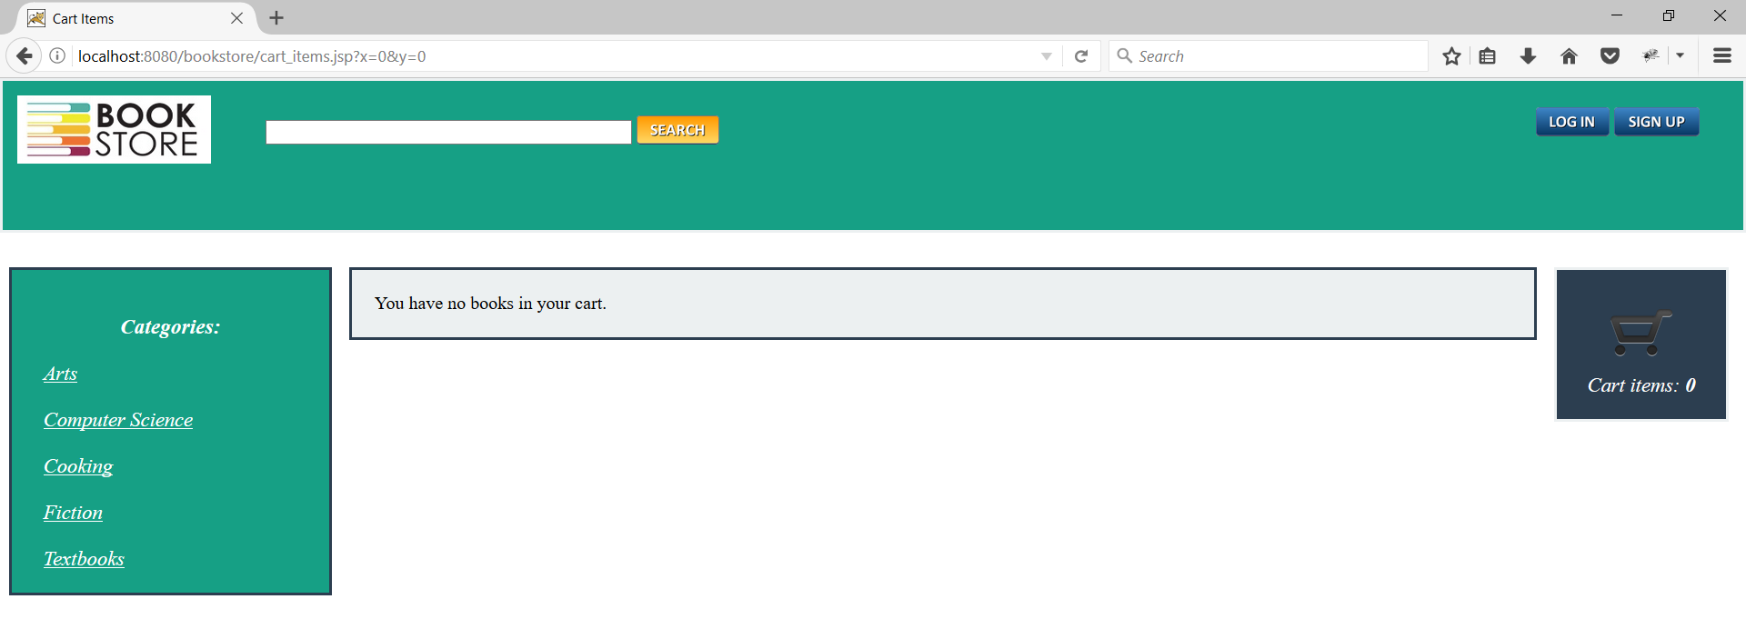

## **Decimal points in Item Prices**

|  |  |  |
| --- | --- | --- |
| Test Case ID: | 3.10. Decimal points in Item Prices | |
| Test Objective: | To check if the decimal in Cart Subtotal is rounded to 2 decimal points | |
| Test Data: | Cart Subtotal | |
| Prerequisites | The Bookstore website should be running | |
| Procedure: | Expected Result | Actual Result |
| 1. User logins to the website using valid username and password 2. User selects the book to be purchased and add to the Cart 3. User selects the cart and checks the Cart Subtotal | The decimal value in Cart Subtotal should be rounded to two decimal points | The decimal value in Cart Subtotal is not rounded to two decimal points |
| Test Case Result: | Fail | |

Selenium IDE Test:

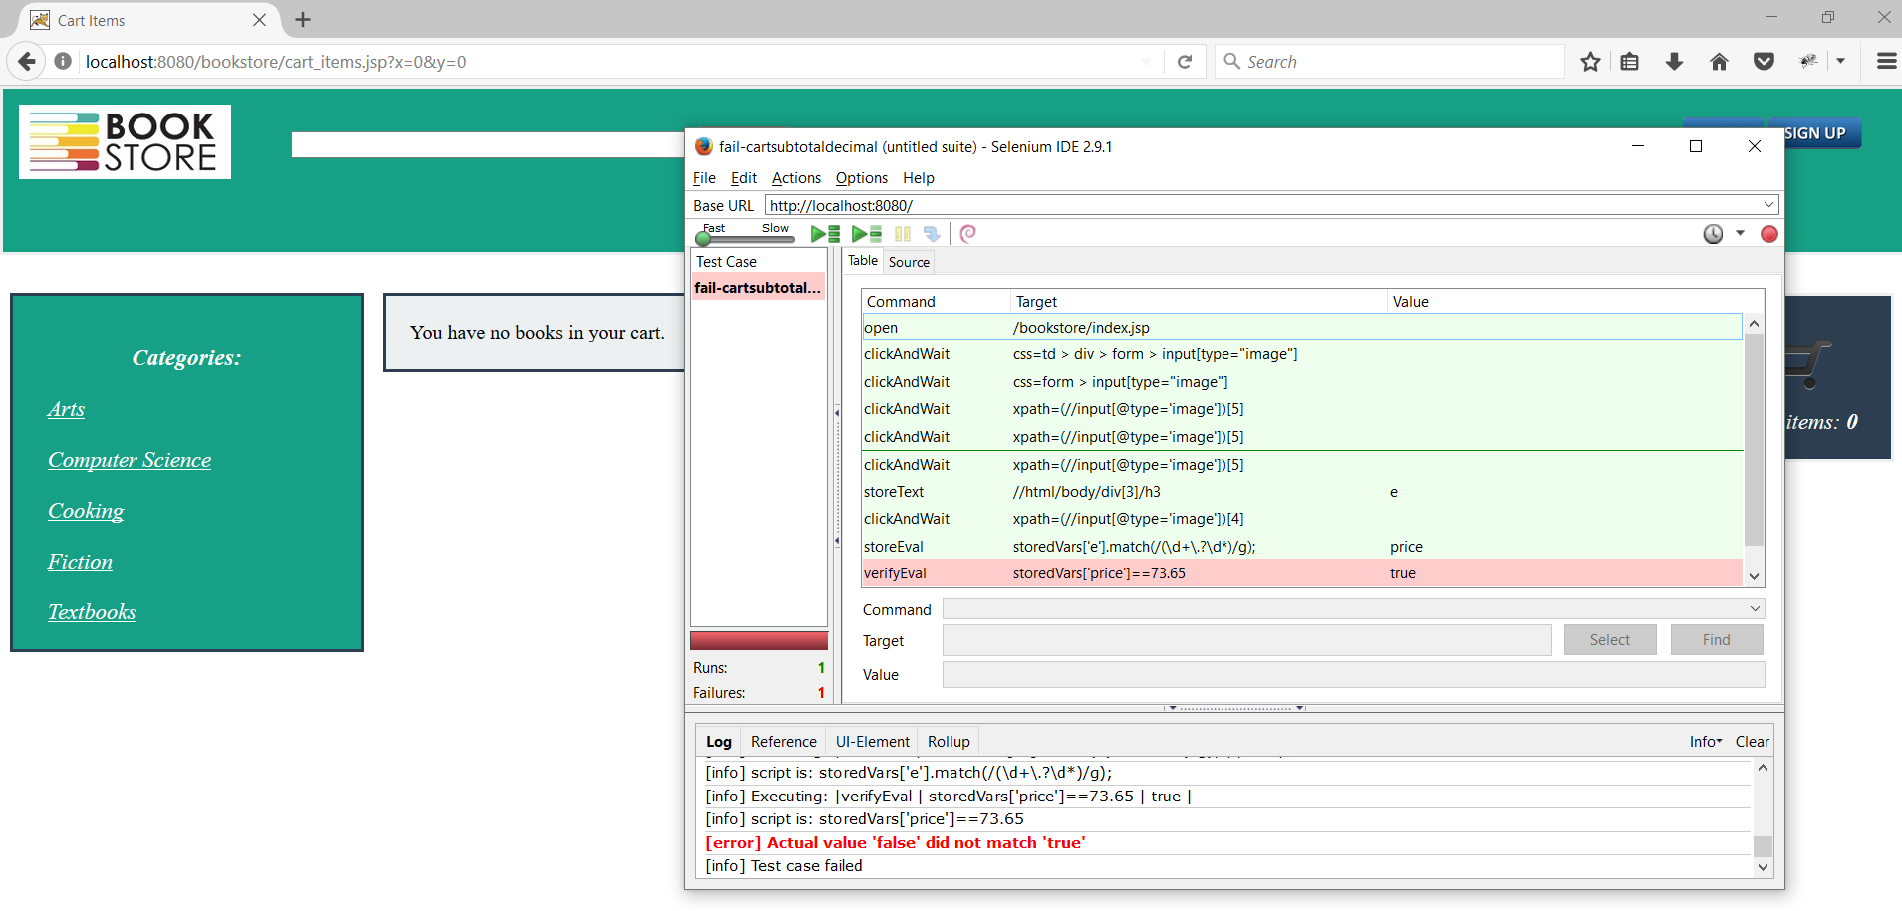

Selenium WebDriver Test:

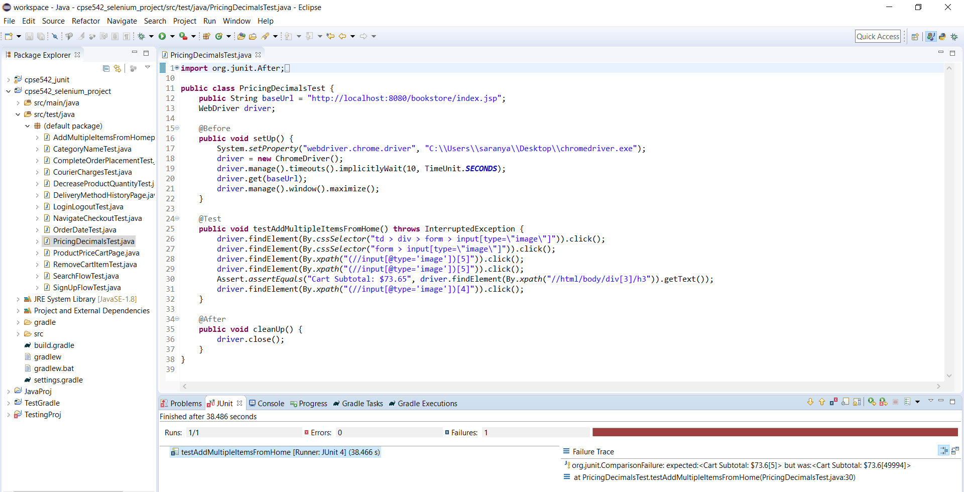

Test Result: The decimal value in Cart Subtotal is not rounded to two decimal points

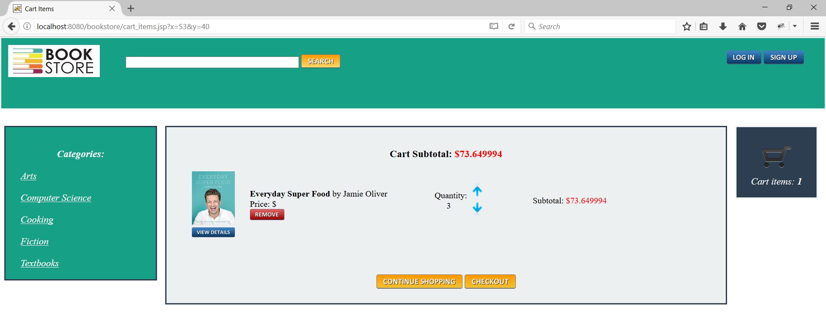

## **Checkout flow**

|  |  |  |
| --- | --- | --- |
| Test Case ID: | 3.11. Checkout flow | |
| Test Objective: | To check if the user can proceed to order checkout | |
| Test Data: |  | |
| Prerequisites | The Bookstore website should be running | |
| Procedure: | Expected Result | Actual Result |
| 1. User logins to the website using valid username and password  2. User selects the book to be purchased and add to the Cart  3. User selects the cart and proceed to order checkout | The user shall be able to select item and checkout | The user can select item and checkout |
| Test Case Result: | Pass | |

Selenium IDE Test:

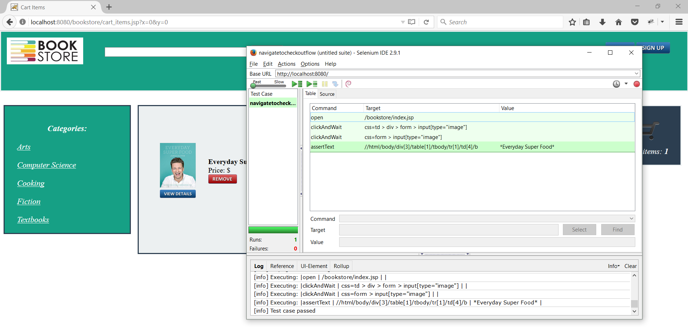

Selenium WebDriver Test:

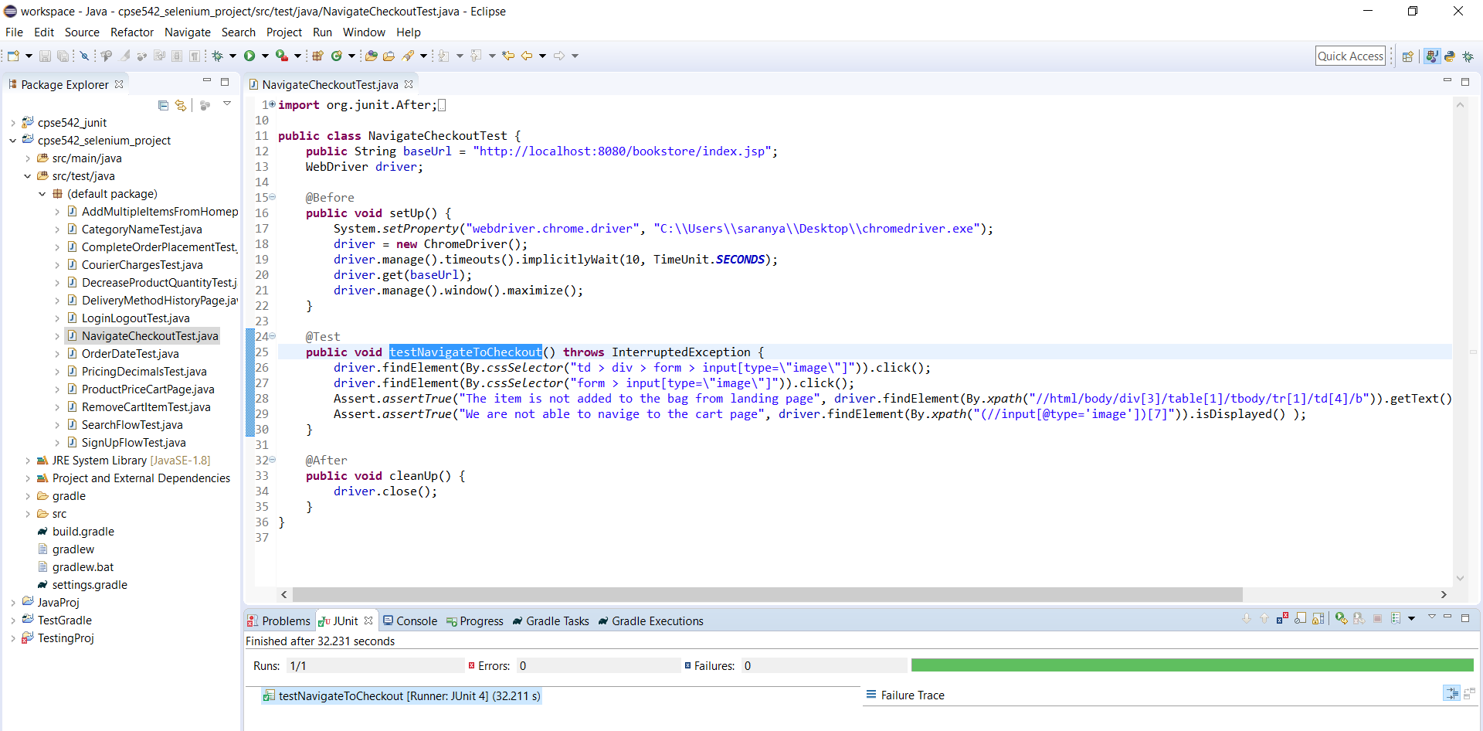

Test Result: The user can select item and checkout

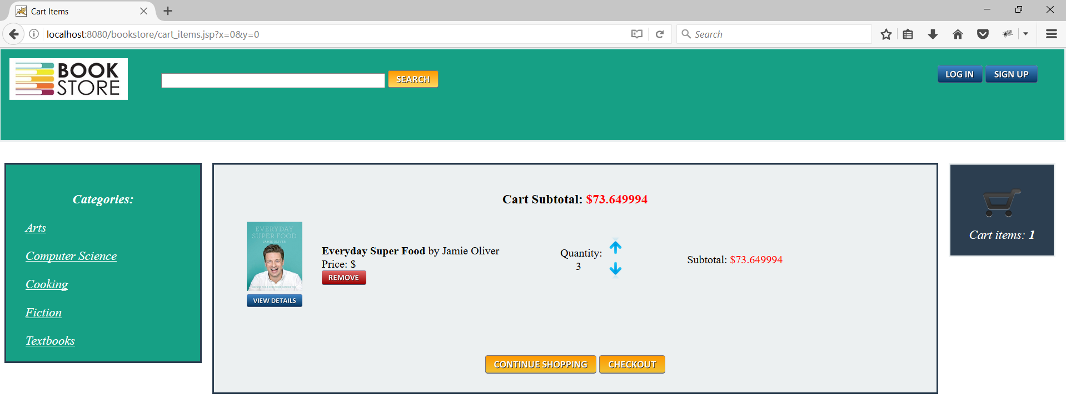

## **Cart Item price not displayed in Order details page**

|  |  |  |
| --- | --- | --- |
| Test Case ID: | 3.12. Cart Item price not displayed in Order details page | |
| Test Objective: | To check if the price of the book can be viewed from the Order details page | |
| Test Data: | Price | |
| Prerequisites | The Bookstore website should be running | |
| Procedure: | Expected Result | Actual Result |
| 1. User logins to the website using valid username and password  2. User selects the book to be purchased and add to the Cart  3. User selects the cart and view the price | The user shall be able to view the price of the book in the Order details page | The user is not able to view the price of the book in the Order details page |
| Test Case Result: | Fail | |
|  |  | |

Selenium IDE Test:

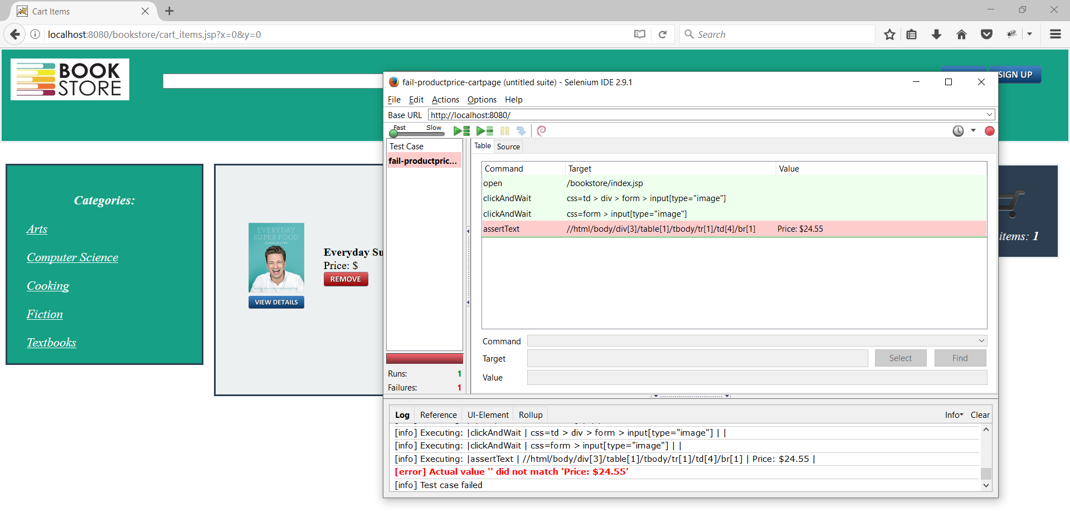

Selenium WebDriver Test:

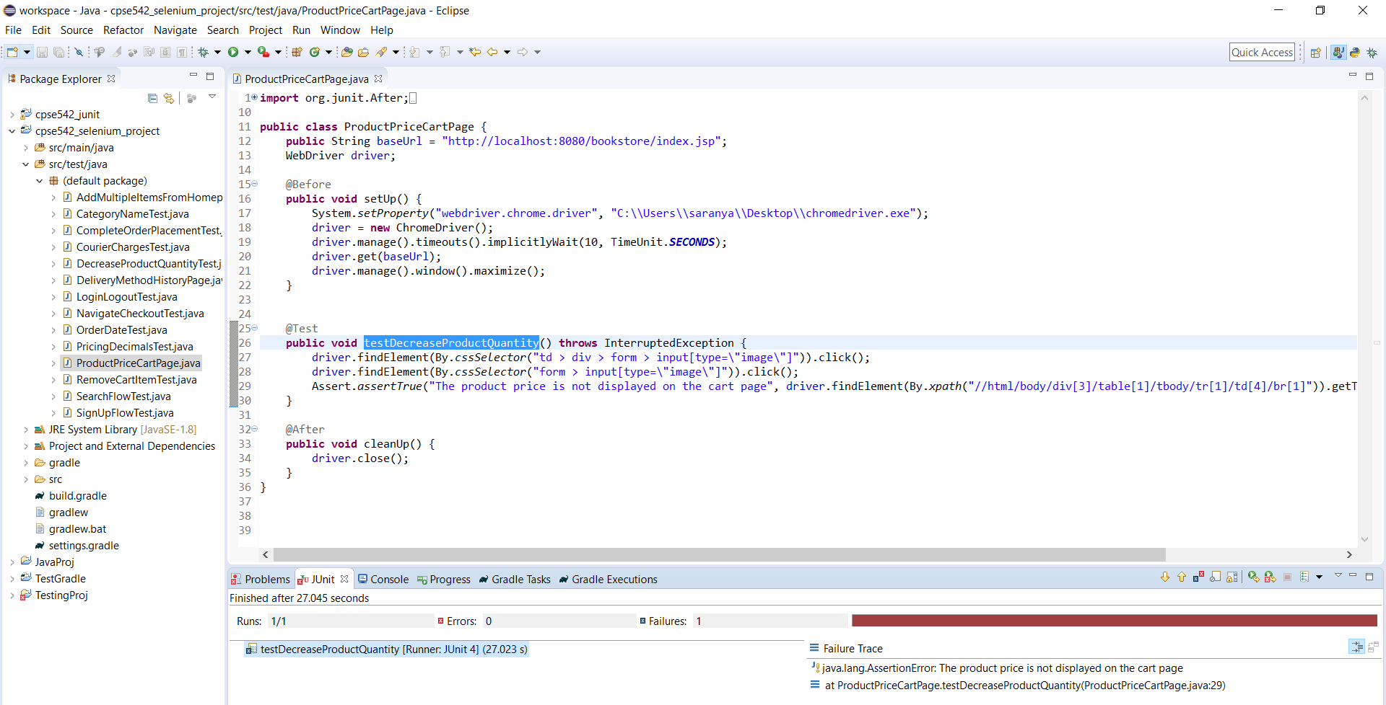

Test Result: The user is not able to view the price of the book in the Order details page

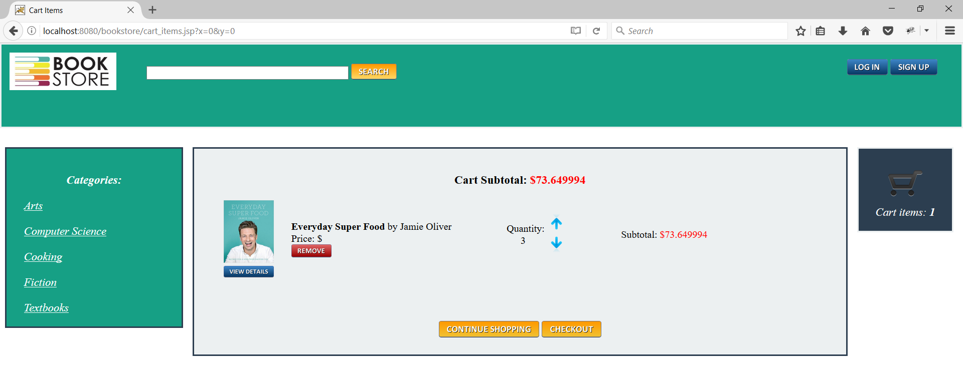

## **Courier charges not calculated**

|  |  |  |
| --- | --- | --- |
| Test Case ID: | 3.13. Courier charges not calculated | |
| Test Objective: | The courier charge should be calculated properly | |
| Test Data: | Order cost including delivery | |
| Prerequisites | The Bookstore website should be running | |
| Procedure: | Expected Result | Actual Result |
| 1. User logins to the website using valid username and password  2. User selects the book to be purchased and add to the Cart  3. User selects the cart and checkout to provide personal details and select courier charge 5$ | The courier charge of 5$ should be calculated properly | The courier charge of 5$ is not  calculated properly |
| Test Case Result: | Fail | |

Selenium IDE Test:

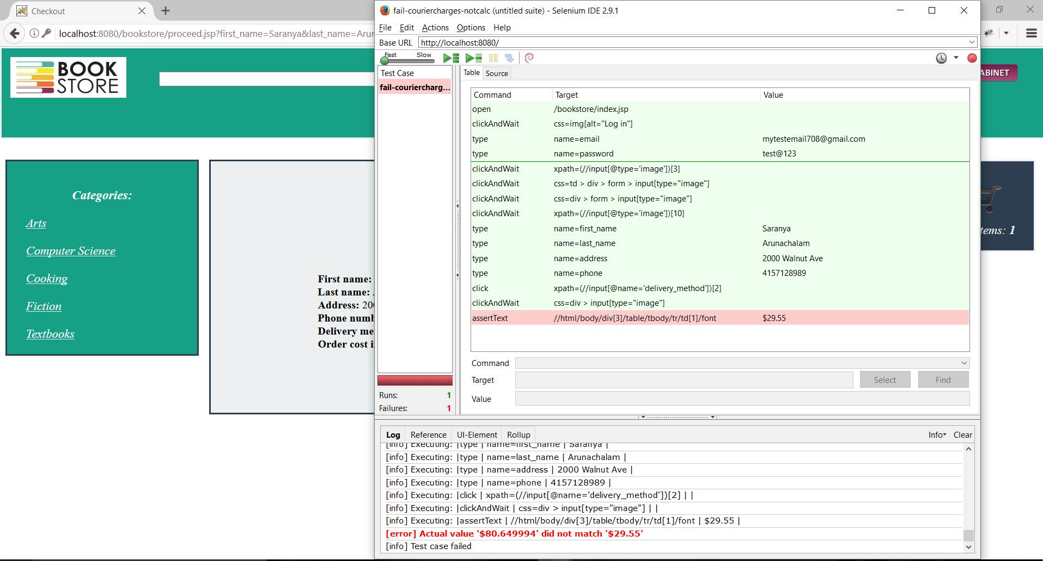

Selenium WebDriver Test:

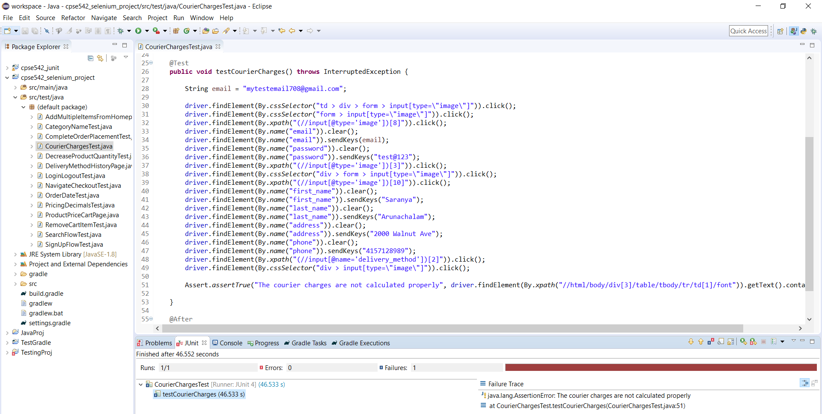

Test Result: The courier charge of 5$ is not calculated properly

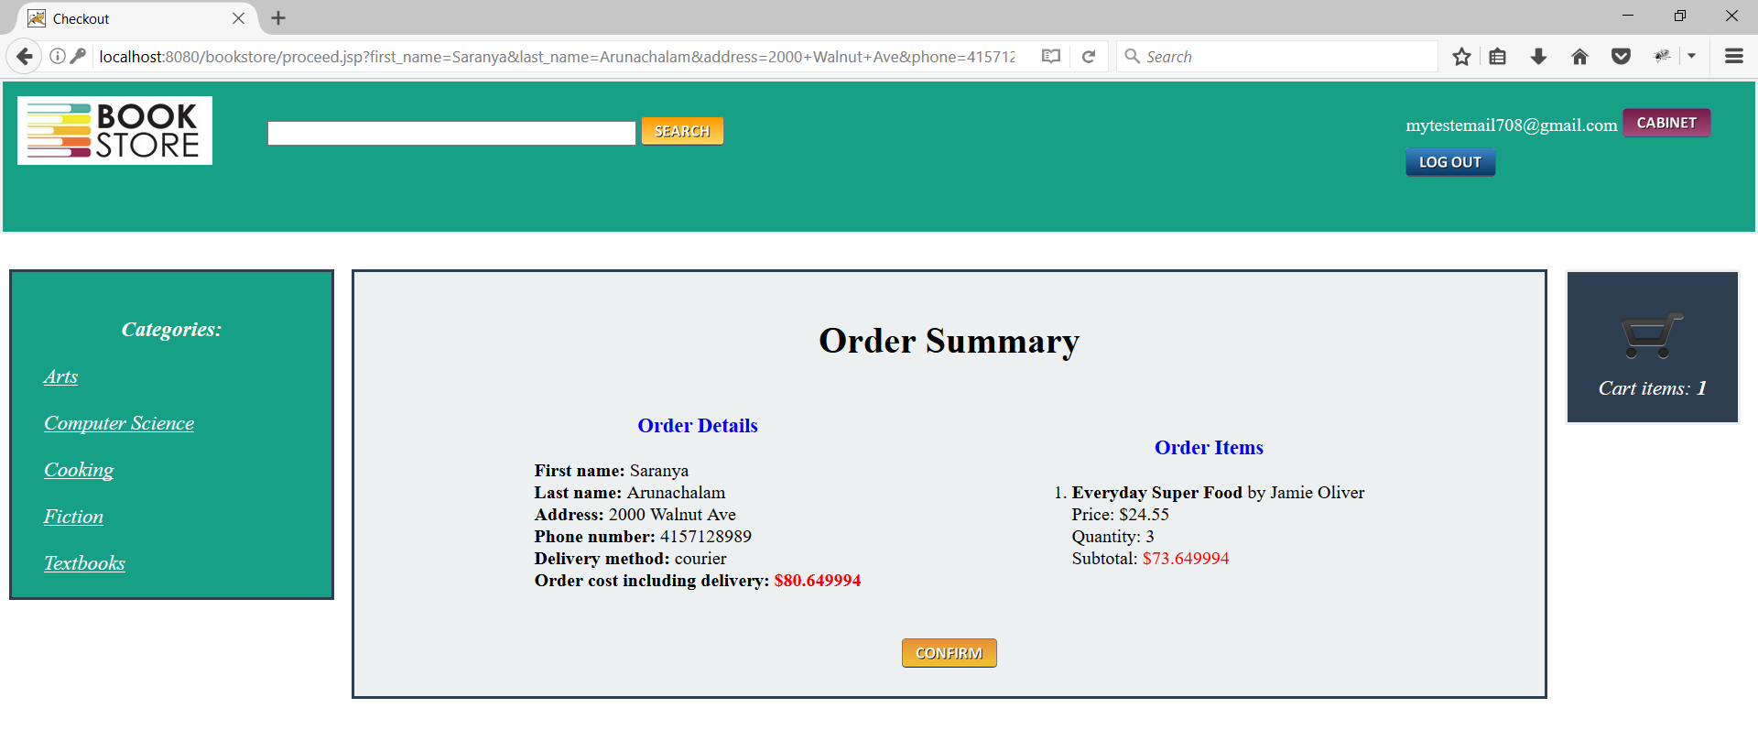



## **Order date issue**

|  |  |  |
| --- | --- | --- |
| Test Case ID: | 3.14 Order date issue | |
| Test Objective: | The order date should be displayed in the correct format | |
| Test Data: | Order Date | |
| Prerequisites | The Bookstore website should be running | |
| Procedure: | Expected Result | Actual Result |
| 1. User logins to the website using valid username and password  2. User selects the book to be purchased and add to the Cart  3. User selects the cart and checkout to provide personal details for delivery  4. User confirms the order summary  5. User checks the order date in the Cabinet | The user shall be able to view the correct order date | The user is not able to view the correct order date |
| Test Case Result: | Fail | |

Selenium IDE Test:

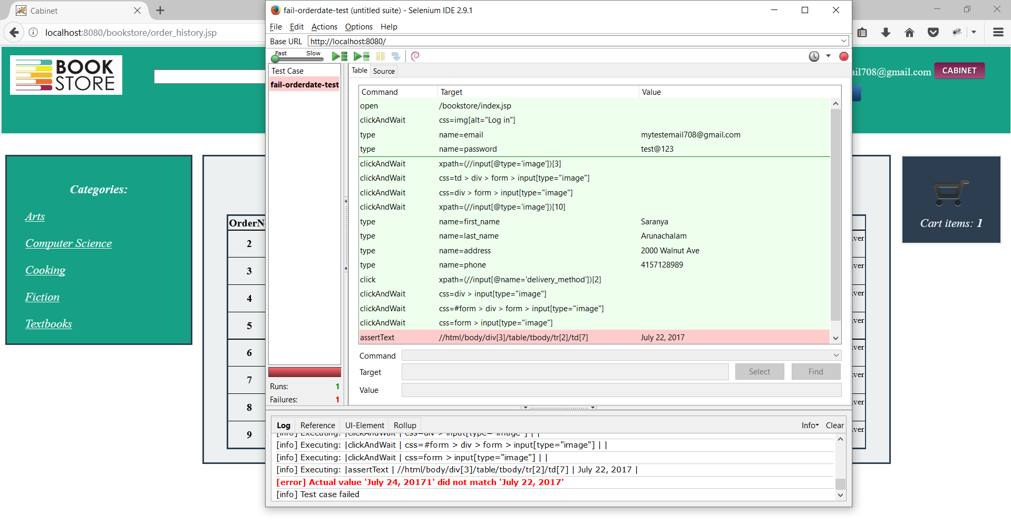

Selenium WebDriver Test:

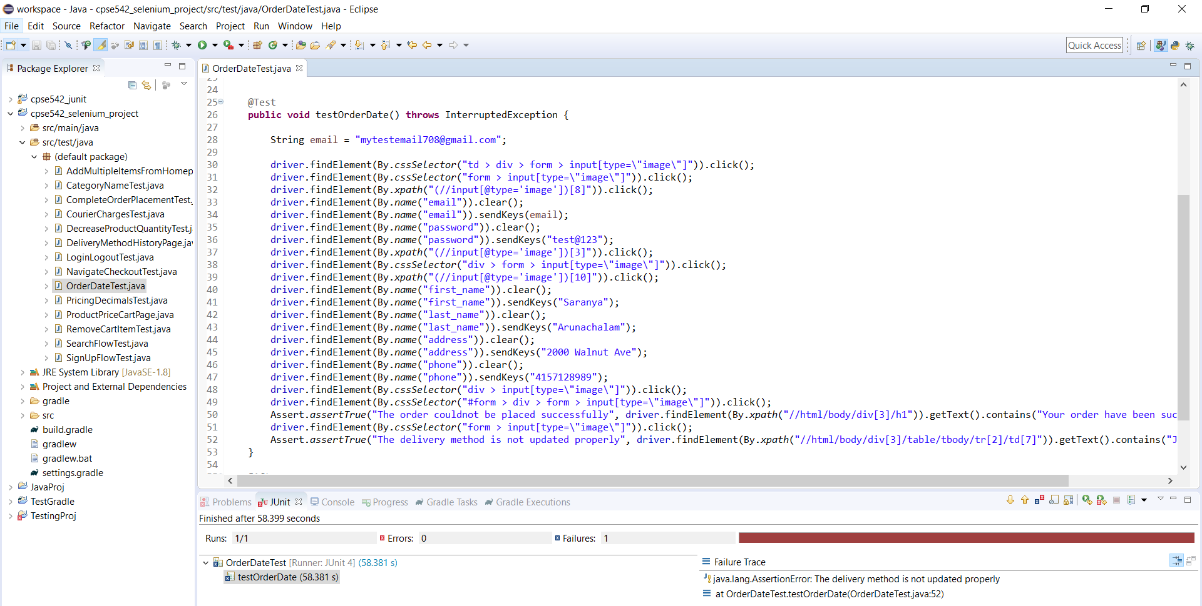

Test Result: The order date is 20171 which is not the correct date format

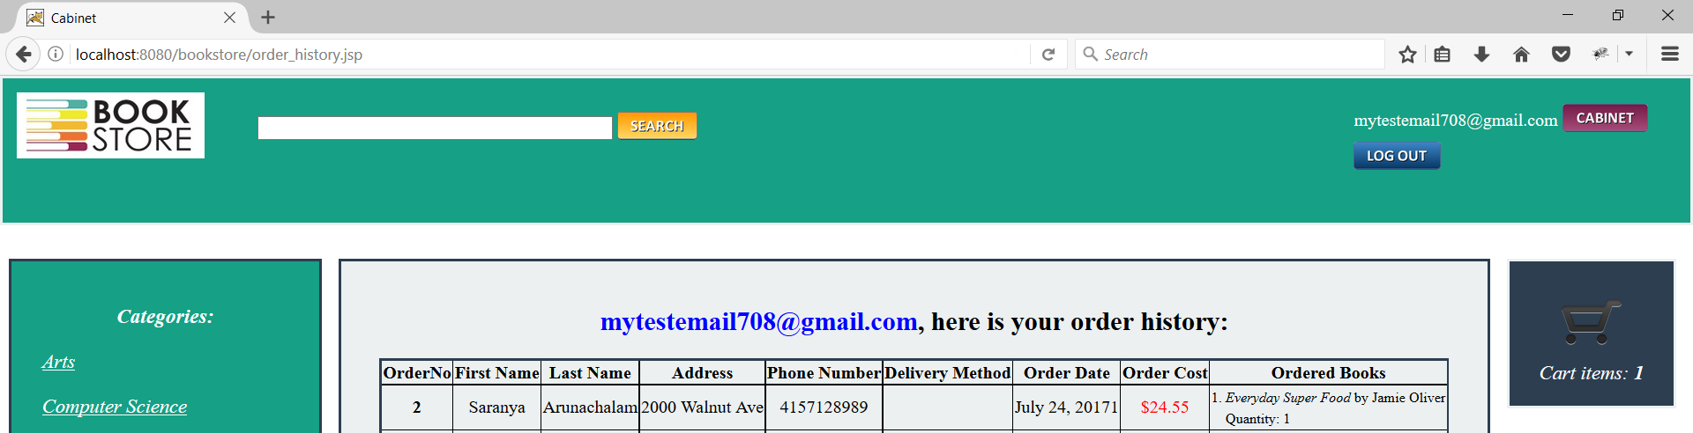

# Pros and Cons of Selenium

Some general Pros and Cons of Selenium compare to other web testing tools are the following:

|  |  |
| --- | --- |
| Pros | Cons |
| API into most popular languages | Requires a selenium server to run the tests |
| Due to its JavaScript based architecture can support many browsers | Ruby API is not so updated |
| Native Xpath support for html that is complicated or full of nesting or with no id attributes. | Runs slower than competitor’s products (water) |
|  | It does not work so well with heavy web apps that are using AJAX |

Selenium IDE:

|  |  |
| --- | --- |
| Pros | Cons |
| Easy to install | Available only for Firefox |
| Does not require programming experience, only knowledge of HTML and DOM | Can only support the creation of prototype tests |
| Exports test for Selenium RC and WebDriver | Cannot use iteration or conditional operations |
| Build-in test results reporting module | Test execution is relatively slow compare to Selenium RC and Web Driver |
| Supports extensions |  |

Selenium RC:

Over the years Selenium RC merged into WebDriver. It is also notable that Selenium RC was the first implementation of web testing using that supported many programming languages. Supported languages are Java, C#, PHP, Python, Perl and Ruby.

|  |  |
| --- | --- |
| Pros | Cons |
| It works on many browsers and platforms (OS X, Linux, Windows) | Not as easy to install as the IDE |
| It is capable of performing looping and conditional operations | Requires programming knowledge |
| Supports data-driven testing | Requires a Selenium RC Server be running |
| It has a stable API that is being around form many years | API has repeated commands that can be confusing |
| It also supports newer browsers | Interaction with the browser is not so visible |
| Faster execution than IDE | Results are not always the same as it uses JavaScript |
|  | The execution is slower than WebDriver |

Selenium WebDriver

WebDriver unlike the Selenium RC, does not depend on JavaScript. Therefore, it has been proven to be a better solution than both IDE and RC, with a more modern a stable mechanism for automating browser’s actions. It can take control of the browser by communicating directly. Supporting languages are the same as Selenium RC.

|  |  |
| --- | --- |
| Pros | Cons |
| Easier to install compare to RC | More difficult installation than IDE |
| Direct communication with browser | Requires programming knowledge |
| More realistic interaction with the Browser | Does not support newer browsers (only by using 3rd party API’s) |
| It does not rely on a separate RC Server | Logging for messages and test results is not a build-in option |
| Faster execution than IDE and RC |  |

Selenium Grid

Major purpose of Selenium Grid is to run tests in parallel which can save a lot of time compared to running the tests one by one. It can distribute the testing jobs using a hub-and-nodes technique.

# Conclusion

After doing a case study on Selenium IDE and Selenium WebDriver helped us to understand the concept and automation testing application. Automated testing is an important concept that allows us to perform automatic tests and compare their actual outcome with expected results by using separate software. This kind of tests can not only automate some recurring, low-level UI tests but also works with more complex tests.

Test that can be automated has many advantages over manual testing. One of the biggest advantages is that after they have been developed, they can be run fast and repeatedly. It saves money in the long term because more tests can be performed in a short time as compared to manual testing and defects can be found quicker. In our opinion, automated tests are more preferred, because later in the project tester mostly focus attention on creating and upgrading the existing test scenarios, instead of on performing the same test manually repeatedly.

Due to increasing demand of web-based applications and agile software development, test automation tools are often used to run a repeatable set of tests against the application. Among the various available open source automated testing tools, Selenium is the most widely used tool for software testing. Above mentioned advantages acted as a motivation for our team to take up the case study of Selenium and try to learn its rich set of testing functions. Since we all were new to automated testing and Selenium tool, we started with Selenium IDE, so that we can get familiar with the Selenium terminology, command and testing process. It provides built in support for Firefox plugin which is an easy-to-use interface, for testing any website.

After getting familiar with the Selenium IDE, we came to know that it always does the same set of tests, repeatedly. The main limitation of Selenium IDE is that it supported in only Firefox browser and doesn't have any of the features to support regression testing with the capability of a programming language such as variables, loops, and abstraction, etc. Selenium WebDriver supports a range of languages, including Java, Perl, Python, C#, Ruby, Groovy, Java Script, etc. It has its script, but it is not limit it to that language only. It provides set of different programming language to developers and testers according to their preference.

After considering above advantages moved we moved on to Selenium WebDriver and used it to perform tests on our target system “Online Bookstore”. Since it is easy to import into modern languages, we used it with Eclipse. Each one of us came up with two test cases and used selenium to code and execute the tests. The tool helped us with our test case assessments and to identify defects with failed results. Since it is important for testers to be able to communicate with different stakeholders among the project, behavioral skills play an equally important role for testing. Therefore, working on a group project also helped us to perform as a team player apart from gaining desired technical skills.

# References

<https://www.guru99.com/introduction-to-selenium.html>

<http://www.seleniumhq.org/about/history.jsp>

<http://www.seleniumhq.org/projects/remote-control/>

<http://www.seleniumhq.org/docs/05_selenium_rc.jsp>

<https://www.protechtraining.com/bookshelf/selenium_tutorial/selenium_remote_control?ncr=1>

<http://www.seleniumhq.org/docs/03_webdriver.jsp>

<http://www.seleniumhq.org/docs/>

<https://www.quora.com/What-are-the-pros-and-cons-of-different-front-end-web-testing-frameworks-such-as-Selenium-or-Watir>

<https://www.guru99.com/introduction-to-selenium.html>

<https://github.com/srgykim/bookstore>

<http://study.com/academy/lesson/what-is-electronic-commerce-definition-types-advantages-disadvantages.html>